Town of Frenchboro
Annual Town Report 2015

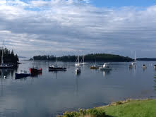
Cove Photo by: Catherine Wolf

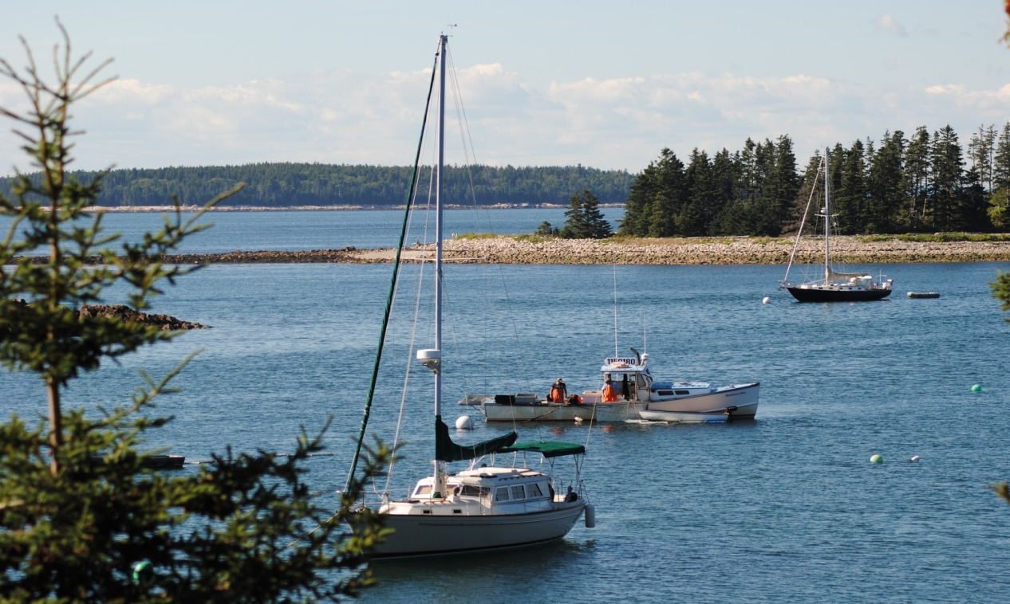
Photo by: Rebecca Lenfestey

1 Executive Drive
Frenchboro, Maine 04635
frenchboro@gmail.com
Town Office: 207-334-2933 Fax 207-334-2971

Rebecca Lenfestey, Town Administrator
frenchboro@gmail.com
207-460-8037

Table of Contents

Cover by (Catherine Wolf).....………………………………..….……….………………………1-2
Table of Contents & Photo by Rebecca Lenfestey…………………….………………………..3
2014-2015 Municipal Officers……………………………………….…….…………………….4-5
Letter from Select Board…….……………………………………...……..…..………………….6-7
Draft Annual Town Meeting Warrant 2015………………………………..…………………..8-19
Town Clerk Report…………………………………………………..……….……………………20
Assessor Report……………………………………………………………..…………………......21
Tax Collector Report…………………………..………………………………………………….22
Frenchboro Library Report………………………………………………………….…………….23
Annual School Report……………..……………………………………………………....……24-26
School Committee Report….……………………………………………………………..…….27-30
Acadia Disposal District…………………………………………………………………………31-36
U.S. Senator King Letter………………………………………………………………………...…37
State Representative Letter……………………………………………………………………......38
2015-2016 School Department Budget…………………………………..………………….....39-43
Treasurer’s Report ………………………..………………………………………………………..44-50
2015-2016 Municipal Budget………………..……………………………..…………....………..51-53
Unpaid Tax List……………………………………………………………………………………...54-55

FY 2014-2105 Town of Frenchboro Officials List

Moderator Duncan Bond

Select Board/Assessors Myron Lenfestey, Jr. (2015)
Vacant (2015)
Zachary Lunt (2016)

Treasurer Rachel Bishop (2015)

Town Clerk/ Registrar of Voters Ann Heikkenan- Fernald (2015)

Tax Collector/ Excise Tax Collector Rachel Bishop (2015)

Harbor Master Jay Fiandeca (2015)

Road Commissioner Select Board

Fire Chief Vacant

Fire Wardens Mike Lenfestey, Jr. (2015)
Rebecca Lenfestey (2016)
Nate Lunt (2017)

School Board Laurette Lunt (2015)
Brianna Gamester (2016)
Beverly Roxby (2017)

Emergency Management Director Rachel Bishop

9-1-1 Street Address Officer Rebecca Lenfestey

Code Enforcement Officer Vacant

Local Plumbing Inspector Vacant

Animal Control Officer Jerry Michaud

Health Officer Chuck Amos ( 2016)

Election Clerks Rachel Bishop
Cheryl Averill

Planning Board Wyatt Beal
David L. Lunt
Travis Lunt
Arthur Fernald
Vacant

2014-2015 Municipal Officers (Continued)

Board of Appeals Joseph Fiandeca
Nate Lunt
Chuck Amos
Rod Bost
Vacant

Municipal Advisory Committees

Harbor Committee: Myron C. Lenfestey, Jr. ( 2016)
Arthur Fernald (2016)
Rod Bost (2016)
Travis Lunt (2015)
Brian Coffay (2015)

Solid Waste Coordinator: Ann Fernald

Waste Management Committee: Beverly Roxby
Ann Fernald
Chuck Amos

Tax Committee: Gerd Hasal
David Lunt
Ann Fernald
Kim Smith
Rachel Bishop
Lauren Baker
Rebecca Lenfestey

Ferry Board Representative: Duncan Bond

Swan’ Island Electric Company Representative: George Baker

Letter from the Select Board

Changes:

This past year has been a busy one, with a lot of effort put into planning for the future of year round sustainable living for Frenchboro residents. We had our Town Clerk, Brianna Gamester step down from her position and Ann Fernald had stepped up to fill that position. We thank Brianna for her time and dedication as Town Clerk, and we thank Ann Fernald for stepping up to fill the vacant position. We also had Select Board member Kim Smith step down from her position, this position remains vacant until the Annual Town Meeting. Thank You Kim Smith for your time on the board.

Projects:

There have been many projects on the horizon that have been given attention this fiscal year.

The town had many job descriptions done, but the Town Administrator spent some time this winter reviewing the job descriptions and updating the information that was in them, and updating some parts of the jobs. New job descriptions were created as suggested by MMA for positions including the Post Office, and the Select board. Rebecca Lenfestey has also spent additional time researching a municipal bond, and what the town would need to do in order to get one for the many projects that need to be done. More time was also spent collaborating with Wright-Pierce on the Small Harbor Improvement Grant and completing an application for this grant to complete a Comprehensive Plan for Frenchboro, This grant requires matching funds, but Rebecca Lenfestey secured the matching funds from Maine Coast Heritage Trust in the amount of $5,000 upon approval of the grant by the State of Maine. Time has also been spent on collaboration with the school on an island fellow application to be shared between the school and the town. The projects that the Island Fellow would be working on for the capacity of the town projects would be to complete the final phase of the Harbor Ordinance and GIS Map a mooring plan of the harbor, they would also help gather information and help with things in regards to the possible merger of SIEC with EMERA, they will help do a study about ways to conserve and better use energy and resources on the island, they will also provide support in the writing and research for the Comprehensive Plan.

During the assessment done on the town by MMA’s Risk Management Department they had given the town a list of things to look at and improve upon and to provide a timeline in which those things could happen. Some of these were an easy fix like smoke detectors, and fire extinguishers, and some have required a little more research to be done to come up with a solution. One immediate need is the state of the Frenchboro Fire Department. Without a Fire Chief, and someone to be in charge, there have been things that have been overlooked in the last couple of years that need to be addressed. This is one thing that should be discussed at the Annual Town Meeting to see what the general sense of the community is regarding this topic; and what direction the community would like to take. Whatever decision gets made, the plan of action needs to be submitted to MMA by July 2015.

The new tax maps are completed thanks to the work of Hope Rowan, and Rebecca Lenfestey. The information that was compiled according to deeds on record were then put in a program that mapped everything out. There are a few adjustments that may need to be made over the upcoming year, and you will see that there will be a budget line item for tax map updates in a minimal amount. Most communities keep some money in the budget each year to make the adjustments on a yearly basis instead of letting the changes pile up. This makes sense, and if the money is not used each year, then it can go back into the carryover. There is a large tax map located at the Municipal Building, and the digital copy will be available at the town website at frenchboro.maine.gov.

Over the course of the year Town Administrator Rebecca Lenfestey has attended a few trainings to help in her roles for the Town of Frenchboro. Rebecca Lenfestey also spent some time, as well as Brianna Gamester, doing training with Ann Fernald to get her through Elections, and the year as Town Clerk. The budget will continue to financially support the training required for all town employees.

As many of you know your tax dollars have been allocated for a few upgrades within the community as well. Some projects have been extensive repairs to the teacher house including new flooring, windows, siding and painting of the interior. With the repairs done this past year at the Ferry Pier, we also had a new electric panel put in. There was some winter damage done to the Municipal Building where many shingles were blown off in a storm, and the Fire Department funds were used to repair those shingles. We also had some help from some amazing community service workers that helped with painting, trash removal, and some work at the school. These volunteers will be back again this summer to work on some more projects. As you know with a limited budget we take advantage of whatever help and resources we can get. Please contact Rebecca Lenfestey if there are ways you wish to support these projects as well, or if you have suggestions of repairs or work that could be done to improve something within the community.

We also had some support to do some repairs to the Public bathroom down by the school thanks to the Long Island Congregational Church. We also had financial support for a water purification system at the community building thanks to the support of FFDC. Thanks to both of those entities for the assistance.

Communication and Collaboration has also continued with MCHT, Island Institute, and Maine Seacoast Mission to help sustain year round living in the Frenchboro Community. This happens in many ways, from presentations in the community, visits from these organizations, monetary support for projects, and Island Fellow placements. The board, and the community are pleased with the continuing support of the organizations.

In the upcoming fiscal year we will be looking at working with bond counsel to secure a bond for the projects that the community feels need immediate attention, more training will be provided to employees, some minor repairs to the Municipal Building, Exploration of a Fire Department or options for the community, new fuel tanks will be purchased for the Municipal Building, continued work on the management of the Frenchboro Town Dock, Float and Harbor Ordinance, final GIS mapping of the harbor and moorings, Comprehensive Plan work, research on alternative energy options, and sustaining the year round community population. There will also be continued conversations and work to continue our full time status for the Frenchboro Post Office.

Conclusion

The board wishes to again take this opportunity to thank the many people and their efforts to keeping Frenchboro a successful year-round community. It takes many hands to keep our community adequately functioning on so many levels, from friendly and neighborly, to volunteerism, and professionalism in town jobs. Many people contribute in each, or all of these capacities; so let’s applaud everyone for our continued success.

Annual Town Meeting 2015 Warrant

THE WARRANT
TOWN MEETING OF FRENCHBORO
JUNE 25, 2015

State of Maine
Hancock County, ss

To: Arthur Fernald, in the Town of Frenchboro, in the County of Hancock, State of Maine

Greetings:
In the name of the State of Maine you are hereby required to notify and warn the inhabitants of Frenchboro, in the said County, qualified by the law to vote in town affairs, to meet in said town at the Municipal Building, on the day of June 25, 2015 at three o’clock in the afternoon to act on the following articles to wit:

Articles to Elect Town Officials

Article 1 To choose one moderator to preside at said meeting.
Written Ballot required.

Article 2 To choose one Selectboard member/Assessor/Overseer of
poor for a two year term. The term of Kim Smith was vacated.
To choose one Selectboard member/Assesssor/
Overseer of the poor for a three year term. The term of
Myron Lenfestey, Jr. expires 2015.
Written Ballot required.

Article 3 To choose one Town Clerk/Registrar of Voters for a one year
term. Current clerk is Ann Fernald.

Article 4 To choose one Tax Collector/Excise Tax Collector for a one
year term. Current Tax Collector is Rachel Bishop.

Article 5 To choose one School Committee member for a two year
term, the term of Laurette Lunt expires 2015.
Written Ballot required.

Article 6 To choose one Fire Warden Committee Member for a three
year term. The term of Myron C. Lenfestey, Jr. expires 2015.

Article 7 To choose one Fire Chief.

Article 8 To choose two Harbor Committee members for one year
terms. The terms of Travis Lunt and Brian Coffay expire. One
member must be a Commercial Fisherman as set forth in the
Frenchboro Town Dock, Float and Harbor Ordinance.

Article 9 To choose any necessary members of the Planning Board
and Board of Appeals. There is one vacancy on each board..

Articles to transfer funds

Article 10 To see if the voters of the Town of Frenchboro will vote to
transfer all unspent Fire Department Operational Budget
funds to the general fund for the fiscal year beginning July 1, 2015 and ending June 30, 2016 excluding the amount that is subject to grant restrictions which will go to the Fire Department Operational Account..

Explanation: Typically this article moves the funds to the reserve for the Fire Department but this money this year will be moved to the general fund to reduce the amount to be raised by taxes for the 2015-2016 fiscal year. The Fire Department Operational Account includes $44,853.69 that is subject to a grant restriction and not able to be used for general purposes. Estimated amount to be turned back to the general fund is estimated at $ 7,380.00.

Article 11 To see what sum if any the voters of the Town of Frenchboro will vote to
Transfer from the Town Roads Operational Account from the
FY 2014-2015 to the Town Roads Operational Account for the
FY 2015-2016.

Explanation: The road paving project didn’t get completed because of the weather in the fall 2014 therefore moving the project forward to this year. If the voters accept the Municipal Bond and Include the roads in that project this money will pay the first loan payment. If the Municipal Bond is denied, then this will still pay the loan payment on just the road projects for the FY 2015-2016.

Select board recommends $24,000.00 the amount moved from reserve to operational at a Special Town Meeting in 2014.

Articles to Approve the Municipal Budget

Note: Please see Appendix A-1 for the line item budget

Article 12 To see what sum the Selectboard is authorized to expend
for Administrative Salaries for the fiscal year beginning
July 1, 2015 and ending June 30, 2016, and to see what
sum the Town will vote to raise and appropriate for the same.

Select board recommends: $ 28,500.00

Article 13 To see what sum the Selectboard is authorized to expend for
Administrative Expenses for the fiscal year beginning July 1, 2015 and ending June 30, 2016, and to see what sum the Town will vote to raise and appropriate for the same.

Select board recommends: $ 33,660.00

Article 14 To see what sum the Selectboard is authorized to expend for
Municipal Building Expenses for the fiscal year beginning
July 1, 2015 to June 30, 2016, and to see what sum the Town will vote to raise and appropriate for the same.

Select board recommends: $ 6,500.00

Article 15 To see what sum the Selectboard is authorized to expend for
Public Works Expenses for the fiscal year beginning July 1, 2015 and ending June 30, 2016, and to see what sum the Town will vote to raise and appropriate for the same.

Select board recommends: $ 56,100.00

Article 16 To see what sum the Selectboard is authorized to expend for Teacher’s House Expenses for the fiscal year beginning
July 1, 2015 and ending June 30, 2016, and to see what sum the Town will vote to raise and appropriate for the same.

Select board recommends: $ 0.00

Article 17 To see what sum Selectboard is authorized to expend for
Fire Department Operational Expenses for the fiscal year
beginning July 1, 2015 and ending June 30, 2016, and to see
what sum the Town will vote to raise and appropriate for the
same.

Select board recommends: $ 3,500.00

Explanation: Where there has been little to no involvement with the Fire Department, the board requested the presence of people at the budget meeting to establish the direction of the Department. With no additional attendance the board has reduced the amount to $3,500.00 to be able to cover the cost of dispatch fees for 9-1-1, and enough funds for an emergency boat trip in the event of a fire.

Article 18 To see what sum of money, if any, the town will vote to raise and appropriate, and expend in Unclassified Accounts:

Select board recommends: $1,315.00

Special Reserve Accounts

Article 19 To see what sum of money, if any, the town will vote to raise
and appropriate for the following Special Reserve Accounts:

a. Road Maintenance
Select board recommends : $0.00
balance in account $ 52,875.16

b. Municipal Building
Select board recommends: $ 0.00
balance in account $ 8,738.72

c. Teacher House
Select board recommends: $ 0.00
balance in account $ 13,477.80

d. Town Floats and Ramps
Select board recommends: $ 0.00
balance in account $ 17,378.24

e. Ferry Pier Hoist
Select board recommends: $0.00
balance in account $ 3,050.80

f. Fire Department
Select board recommends: $ 0.00
balance in account $ 10,379.43

g. EMT Training
Select board recommends: $ 0.00
balance in account $ 1,500.00

h. Attorney
Select board recommends: $ 0.00
balance in account $ 10,900.00

i. Gravel Pit
Select board recommends: $ 0.00
balance in account $ 12,182.54

Articles to transfer funds from Reserve Accounts to Operational Accounts

Article 20 To see what sum of money, if any, the town will vote to
move from the Teacher House Reserve Account to the
Teacher House Operational Account.

Select board recommends $ 2,500.00

Explanation: Instead of raising new funds, this amount will be
moved to cover any minor expenses for the 2015 fiscal year.

Article 21 To see what sum of money, if any, the town will vote to move
from the Municipal Building Reserve Account to the
Municipal Building Operational Account.

Select board recommends $ 4,000.00

Explanation: Instead of raising new funds, this amount will be
moved to cover minor building upgrades for the 2015 fiscal
year.

Article 22 To see what sum of money, if any, the town will vote to move
from the Attorney Reserve Account to the Attorney
Operational Account.

Select board recommends $ 4,000.00

Explanation: Instead of raising new funds, this amount will be
moved to cover the cost of the Bond Counsel for the purpose
of a Municipal Bond.
Article 23 To see if the Town of Frenchboro will vote to Authorize the
Select Board to pay for Bond Counsel, who will write articles for a Special Town Meeting Warrant, and then file the proper paperwork for the purpose of a Municipal Bond for the following work to be completed.

- Completion of the Town Wharf estimated at
$ 100,000.00
- Complete fix of town road in the housing development
estimated at & other potholes $ 125,000.00

c. Ditch, Drain, & Guardrail Work $ 60,000.00

d. Bond Counsel Work $ 15,000.00

The total Municipal Bond if all of these projects are approved would be $ 300,000.00. The passing of this article gives the board permission to move forward with an attorney to draft the articles needed for a Special Town Meeting, and for the following work to be completed by December of 2016. This requires passage of Article 21 to pay the attorney to complete up front work, and then the rest will be paid for out of the bond.
Article 24 To see what sum of money, if any, the town will vote to
appropriate from the following General Fund Revenue
sources to be used towards the 2015-2016 budget
appropriations thereby decreasing the amount required to be
raised by property taxes.
Select Board recommends:
Excise Tax
Auto | $ 5,884.62
Excise Tax Fees
Auto | $ 76.58
Boat | $ 6.00
Exemption Reimbursements | $ 4,960.00
State Revenue Sharing | $ 3,573.73
Tree Growth | $ 869.25
Earned Interest | $ 590.82
Travel Reimbursements-School | $ 477.50
Waste Mgt. Income | $ 98.98
Lien Fees | $ 881.16
Payment in Lieu of Taxes | $ 10,000.00
Total Income: | $ 27,418.64
Treasurer’s Note: At the end of the Fiscal Year, the following revenue related entries are made: Boat Excise Income goes to the Town Wharf Reserve Income Account; Transportation and Urban Renewal Income goes to the Road Reserve Income Account; Teacher’s House Income goes to the Teacher’s House Reserve Income Account; Fire Department Income goes to the Fire Department Reserve Income Account; and Gravel Pit income goes to the Gravel Pit Reserve Income Account. These adjustments are all authorized b Town Meeting votes from previous years.

Article 25 To see what sum, if any, the voters will appropriate from the
General Fund to be used toward the budget appropriations thereby
decreasing the amount required to be raised by property taxes.

Explanation: All the unexpended monies and debit from the FY 2014-2015
will go back into the General Fund. The current estimate for
the amount of money that will go back into the General Fund
$ 27,418.64. This amount does not take into consideration any
transfer of funds from operational to reserve accounts
previously voted in warrant.
Select board recommends passage.

Article 26 To see if the town will vote to appropriate any non-dedicated funds
Received to be used toward the budget appropriations thereby
Decreasing the amount required to be raised by property taxes.

Select board recommends passage.

Note: Articles 10 - 26 authorize a total budget of $ 129,575.00

School Related Articles

FRENCHBORO SCHOOL DEPARTMENT

Articles

Note: Articles 27 through 37 authorize expenditures in cost center categories

Article 27 To see what sum the School Committee is authorized to expend for Regular Instruction for the fiscal year beginning July 1, 2015 and ending June 30, 2016.

School Committee recommends $ 92,605

Article 28 To see what sum the School Committee is authorized to expend for Special Education for the fiscal year beginning July 1, 2015 and ending June 30, 2016.

School Committee recommends $ 18,441

Article 29 To see what sum the School Committee is authorized to expend for Career and Technical Education for the fiscal year beginning July 1, 2015 and ending June 30, 2016.
School Committee recommends $ -0-

Article 30 To see what sum the School Committee will be authorized to expend for Other Instruction for the fiscal year beginning July 1, 2015 and ending June 30, 2016.

School Committee recommends $ -0-

Article 31 To see what sum the School Committee is authorized to expend for Student & Staff Support for the fiscal year beginning July 1, 2015 and ending June 30, 2016.

School Committee recommends $ 11,238

Article 32 To see what sum the School Committee is authorized to expend for System Administration for the fiscal year beginning July 1, 2015 and ending June 30, 2016.

School Committee recommends $ 7,862

Article 33 To see what sum the School Committee is authorized to expend for School Administration for the fiscal year beginning July 1, 2015 and ending June 30, 2016.

School Committee recommends $ 13,957

Article 34 To see what sum the School Committee will be authorized to expend for Transportation & Buses for the fiscal year beginning July 1, 2015 and ending June 30, 2016.

School Committee recommends $ 11,100

Article 35 To see what sum the School Committee is authorized to expend for Facilities Maintenance for the fiscal year beginning July 1, 2015 and ending June 30, 2016.

School Committee recommends $ 18,565

Article 36 To see what sum the School Committee will be authorized to expend for Debt Service and Other Commitments for the fiscal year beginning July 1, 2015 and ending June 30, 2016.

School Committee recommends $ -0-

Article 37 To see what sum the School Committee will be authorized to expend for All Other Expenditures for the fiscal year beginning July 1, 2015 and ending June 30, 2016.

School Committee recommends $ -0-

Note: Articles 27 – 37 authorize a total budget of $ 173,768

Note: Articles 38, 39 & 40 raise funds for the Proposed School Budget

Hand Count

Article 38 To see what sum the voters of the Town of Frenchboro will appropriate for the total cost of funding public education from kindergarten to grade 12 as described in the Essential Programs and Services Funding Act (Recommend $75,404) and to see what sum the voters of the Town of Frenchboro will raise as the Town’s contribution to the total cost of funding public education from kindergarten to grade 12 as described in the Essential Programs and Services Funding Act in accordance with the Maine Revised Statutes, Title 20-A, section 15688 for the period July 1, 2015 to June 30, 2016.

School Committee recommends $66,228

Explanation: The Town of Frenchboro’s contribution to the total cost of funding public education from kindergarten to grade 12 as described in the Essential Programs and Services Funding Act is the amount of money determined by state law to be the minimum amount that a municipality must raise in order to receive the full amount of state dollars.

Hand Count

Article 39 To see what sum the voters of the Town of Frenchboro will raise and appropriate for the annual payments on debt service previously approved by the legislative body for non-state-funded school construction projects, non-state funded portions of school construction projects and minor capital projects in addition to the funds appropriated as the local share of the Town of Frenchboro’s contribution to the total cost of funding public education from kindergarten to grade 12 for the period July 1, 2015 to June 30, 2016.

School Board recommends $ -0-

Explanation: Non-state-funded debt service is the amount of money needed for the annual payments on the Town of Frenchboro’s long-term debt for major capital school construction projects and minor capital renovation projects that are not approved for state subsidy.

Written Ballot Vote Required

Article 40 To see what sum the voters of the Town of Frenchboro will raise and appropriate in additional local funds for school purposes (Recommend: $ 64,335) for the period July 1, 2015 to June 30, 2016, which exceeds the State’s Essential Programs and Services allocation model by (Recommend: $62,492) as required to fund the budget recommended by the school committee.

The School Committee recommends $ 64,335 for additional local funds and gives the following reasons for exceeding the State’s Essential Programs and Services funding model by $ 62,492: The State funding model underestimates the actual costs to fully fund the 2015-2016 budget.

Explanation: The additional local funds are those locally raised funds over and above the Town of Frenchboro’s local contribution to the total cost of funding public education from kindergarten to grade 12 as described in the Essential Programs and Services Funding Act and local amounts raised for the annual payment on non-state funded debt service that will help achieve the Town of Frenchboro’s budget for educational programs.

Note: Articles 38, 39 & 40 raise a total town appropriation of $ 130,563

Note: Article 41 summarizes the proposed school budget and does not authorize any additional expenditures
Hand Count

Article 41 To see what sum the voters of the Town of Frenchboro will authorize the School Committee to expend for the fiscal year beginning July 1,2015 and ending June 30, 2016 from the Town’s contribution to the total cost of funding public education from kindergarten to grade 12 as described in the Essential Programs and Services Funding Act, non-state-funded school construction projects, additional local funds for school purposes under the Maine Revised Statutes, Title 20-A, section 15690, unexpended balances, tuition receipts, state subsidy and other receipts for the support of schools.

School Committee recommends $ 173,768

Article 42 In addition to the amount in Articles 25 – 39, shall the School Committee be authorized to expend such other sums as may be received from federal or state grants or programs or other sources during the fiscal year 2015-2016 for school purposes provided that such grants, programs or other sources do not require the expenditure of other funds not previously appropriated?

Current Year Totals: $ 19,987 School Committee recommends passage.

Article 43 To see if the voters of the Town of Frenchboro will authorize the school
committee to have the Frenchboro Elementary School remain open for
the 2015-2016 school year with a projected enrollment of approximately three students.

School Committee recommends passage.

Municipal Operational Articles

Article 44 To see if the Town of Frenchboro will vote to authorize the Select
Board to apply for grants,approve the acceptance of grants, receive grants, and expend grant funds for the purpose stated in the grant provided that the acceptance of any funds requiring a match from Town funds would require town meeting approval.

Select board recommends passage.

Article 45 To see if the Town of Frenchboro will vote to authorize the Select
Board on behalf of the Town, to sell and dispose of any Real Estate acquired by the Town for nonpayment of taxes, thereon, on such terms as they deem advisable, and to execute quit claim deeds for the property.

Select board recommends passage.

Article 46 To see if the voters of the Town of Frenchboro will authorize the
Select Board to dispose of Town-owned personal property with
value of $5,000.00 or less under such terms as the Board deems
advisable.

Select board recommends passage.

Article 47 To see if the voters of the Town of Frenchboro will vote to exceed
the property tax levy limit established for Frenchboro by State law.
Written Ballot Required

Explanation: Current calculations indicate that Frenchboro will not exceed its
2014 property tax levy limit; however, this article is a precaution in the event that it
becomes necessary to exceed this amount for the next fiscal year.

Select board recommends passage.

Article 48 To see if the voters of the Town of Frenchboro will fix the dates
when taxes are due and payable and to see if the Town will fix a
rate of interest to be charged on taxes after that date:

Select board recommends November 1, 2015 and 7% or the maximum
amount determined by the State Treasurer, whichever is less.

Article 49 To see if the voters of the Town of Frenchboro will establish a
maximum interest rate to be paid on abated taxes:

Select board recommends 3% or the maximum amount determined by the
State Treasurer, whichever is less.

Article 50 To see if the voters of the Town of Frenchboro will vote to authorize
the tax collector to accept prepayments of taxes not yet committed,
pursuant to 36 M.R.S. §506.

Select board recommends passage.

Article 51 To see if the voters of the Town of Frenchboro will accept
a donation from Maine Coast Heritage Trust, and use that amount
to be a match for the Shore and Harbor Improvement Grant.

Explanation: The Town Administrator will be working with the company Wright-Pierce, the board, and the Island Fellow to research, hold meetings, and write a Comprehensive Plan for the Town of Frenchboro.

Explanation: This is contingent upon the approval for our application with the State of Maine.
Select Board recommends passage.

Article 52 To see if the voters of the Town of Frenchboro will form an advisory
group to collaborate with Town Officials to develop a future plan
for Fire Protection for the Town of Frenchboro.

Explanation: In the past year there has been little to no activity for the Department. It is problematic that we have an ordinance for a Fire Department, and Maine Municipal Association evaluates our risk management based on the current state of a Fire Department. The town was cited for compliance issues with the Department in 2014, and a response to MMA is required to update them on how we plan to solve the problems by July 2015. This has been brought to the town for discussion because there are many views, and information to consider in any direction this may go. However, the unfortunate part is there is no easy solution to this situation, but the Town is required to have a formal plan to present to MMA. The board would suggest a group of people to collaborate with the new island fellow, the Town Administrator, and other officials to research what options are available, and to form a proposal to bring before the board and the town on or before the Annual Town Meeting of 2016.

Article 53 To choose 5 members for a one year term for a Frenchboro
Fire Department Advisory Committee.

Select Board recommends passage.

Town Clerk Report 2014-2015

Births 0
Deaths 0
Marriages 0

Dog Licenses:
2 M/F
1 N/S

Elections:
6/10/2014 Primary Election
6/26/2014 Annual Town Meeting
8/11/2014 Special Town meeting
10/20/2014 Special Town Meeting
11/04/2014 General/Referendum Election

Respectfully submitted,
Ann Heikkinen-Fernald, Town Clerk

Assessor Report

Valuation: 2013-2014 2014-2015

State Valuation $ 11,800,000.00 $ 12,950,000.00
Taxable Land Valuation $ 11,027,400.00 $ 10,534,000.00
Taxable Improvement Value $ 6,046,000.00 $ 6,014,300.00
Total Taxable Valuation $ 17,073,400.00 $ 16,548,300.00
% of State Valuation

Appropriations:

County Tax $ 4,542.90 $ 4,800.00
Municipal Appropriations $ 155,149.00 $ 134,951.50
School Appropriations $ 136,591.00 $ 144,831.00
Total Appropriations $ 296,282.90 $ 284,582.50

Deductions:

Homestead Reimb. $ 1,440.00 $ 1,500.00
State Municipal Rev. Share $ 4,353.63 $ 5,629.80
BETE Reimbursement $ 8,184.57 $ 4,210.50
Other Revenue $ 51,420.16 $ 28,458.01
Total Deductions $ 60,054.87 $ 39,798.31
Commitment:
Maximum Amount to be raised $ 253,001.65 $ 263,019.42
Max. Mil Rate 0.014477 0.015968
Min. Mil Rate 0.013787 0.014732
Chosen Mil Rate 0.014400 0.015000
Overlay $ 10,709.09 $ 4,563.31
Total to be raised $ 242,292.56 $ 258,454.11

TAX COLLECTOR’S REPORT
FY 2014-15

Real Estate Taxes Assessed 2014-15 $ 249,349.50
Collected 2014-15 $ 207,196.36
Collected 2013-14 $ 18,680.44
Collected 2012-13 $ 22,331.30
Collected 2011-12 $ 4,002.10
Interest Collected $ 6,004.82
Lien Fees Collected $ 881.16

Excise Tax Collector’s Report

Vehicle Excise $5,884.62
Fees $ 76.58
Boat Excise $ 417.50
Fees $ 6.00

Respectfully Submitted,
Rachel Bishop,
Tax Collector

Frenchboro Library Report 2015

The Frenchboro Library tried a new approach to save fuel but remain available this winter. Keys were made for those needing them like the school teacher and others who expressed interest. We will evaluate this approach this summer and make adjustments if necessary. The library funding has adequately covered our utility expenses. This past year's donations have again allowed the library to add new books to it's shelves. Rod Bost and Bob Roxby provided the time and expertise to keep the Internet service up and running. The library hosted several community meetings including the ones for the lobster dinner committee and the Island Reader and Writers.

Respectfully Submitted,
Marlys Amos

Annual Report for the AOS Board December 2014

We are pleased to share that educators across the district are working diligently to improve teaching and learning for our students. We also recognize the challenges we face and are committed to improving student engagement, reducing dropout rates and ensuring quality implementation of new initiatives.
Big Picture
Looking Back  (December 2013 to December 2014) | Looking Ahead  (December 2014 to December 2015)
• Hired Joshua Young as MDIRSS educational technology coordinator  • Highlighted progress, established future objectives and updated three-year school/district improvement plan  • State and federal grants submitted and approved  • Renewed commitment and effort to strategically use resources  • Successfully recruited and provided targeted support for a large cohort of high quality new teachers across the district  • Initiated work on new Supervision and Evaluation process | • Complete revisions to the Supervision and Evaluation process for Teachers/Principals; submit plan for approval to State DOE  • Continue to strengthen standards-based curriculum, assessment, instruction and reporting initiatives leading to a Proficiency-based Diploma  • Continue to explore changes to the AOS structure, cooperative initiatives among towns, and opportunities to improve efficiency and effectiveness

Goal 1: Improve Student Achievement and Engagement in School
Rationale: Success in the 21st century requires students to leave their K-12 educational experience with high levels of literacy and numeracy. As a district and at each school we need to be engaged in a cycle of improvement to better serve more and more of our students each year. Programming (curriculum, course of study, pathways, RTI (Response to Intervention), etc.), therefore, needs to be specifically targeted to improving reading, writing, mathematics, critical thinking and student engagement and all new and existing programs of study should be measured by how well they contribute to improvement in these five areas. Parents need to be informed and actively involved as partners with the schools in their children’s education.
Looking Back  (December 2013 to December 2014) | Looking Ahead  (December 2014 to December 2015)
• Created alternatives to expulsion for certain misconduct  • Implemented new curricula in the areas of math and writing and established a new standards-based scope and sequence for Science and Social Studies  • Refined process for Gifted and Talented identification for Art and Music  • Worked to ensure that Special Education and Title 1 plans align with the proficiency standards while maintaining the focus on individual student needs  • Increased collaboration with local organizations to create community based learning opportunities that benefited our students and communities | Ongoing focus to improve student achievement through:  • Development of standards-based reporting system that provides clear, useful feedback to students, parents and teachers  • Improved use of data and technology to support differentiated instruction  • Clarification of the importance of foundation and essential standards to guide decision making in the areas of curriculum and instruction  Ongoing focus to improve student engagement through:  • Expanding alternative pathways toward high school graduation  • Implementing comprehensive, targeted intervention process  • Continuing ongoing efforts to meet the academic and emotional needs of ALL students

Goal 2: Improve Teaching and Learning
Rationale: Research shows that quality teaching is the most important variable in student achievement. Skilled teachers who are supported by administrators, have quality teaching materials, have access to and use timely data about student learning, and who actively participate in ongoing professional development make the difference for students. Therefore, it is important that the district prioritize teacher development and support.

Looking Back  (December 2013 to December 2014) | Looking Ahead  (December 2014 to December 2015)
• Offered well attended summer and school year opportunities for professional development for teachers, staff and administrators  • Continued to provide support to teachers on improving student writing and writing instruction  • Increased number of trained teacher mentors  • Confirmed essential standards in all content areas and identified foundation and focus Standards  • Increased the number of teacher leaders across grade levels and content areas in order to:  -maximize opportunities for professional learning  -widen teacher engagement in decision making  - improve consistency and calibration of practices to ensure quality instruction across the district  • Increased emphasis on instructional leadership by building level administrators, including more time in classrooms and prompt feedback for teachers | • Pilot and then submit plan to the state for revised MDIRSS teacher/principal supervision and evaluation process; begin full implementation in Fall 2016-17  • Continue to explore more flexible instructional delivery options system wide K-12  Provide professional development opportunities to:  • Focus on use of high impact instructional practices to improve instruction K-12 in all content areas  • Focus on how to explicitly teach and integrate complex reasoning skills into all content area instruction  • Strengthen systematic teaching of executive functioning skills K-12

Goal 3: Become More Strategic With Resource Allocation, Use of Personnel and Financial Planning
Rationale: MDIRSS is committed, as are its schools, to providing students with an excellent education. However, resources are not unlimited and must be used wisely. Health insurance and maintenance costs continue to rise. Enrollment fluctuates but has been decreasing in some of the district schools resulting in the need to look closely at budgets and use of personnel. Advances in technology enables us to think differently about course delivery, communication, professional development, resource sharing and infrastructure upgrades. The community offers rich resources that the schools can utilize. Preparing students for careers, college and citizenship in the 21st century in a time when resources are finite requires strategic planning and coordinated resource management.

Looking Back  (December 2013 to December 2014) | Looking Ahead  (December 2014 to December 2015)
• Achieved positive audits for all 10 budgets  • Studies underway of alternative organizational structure (AOS), possible advantages and drawbacks to forming a common middle school, single employer option for insurance savings, and options for student transportation  • Completed capital improvements for specific schools (Conners Emerson and Cranberry Isles)  • Improved consensus and collaboration among schools regarding wellness policy and food services program  • Adjusted “specialists” positions in response to declining enrollment  • Redesigned Social Worker position to address specific needs while allowing crisis access for all schools | • Complete renovations for specific schools (Longfellow, Frenchboro, MDIHS paving)  • Explore feasibility of additional technology systems to improve efficiency across the district  • Continue to explore collaborative practices to responsibly manage fiscal impact on our communities (examples: heating oil, insurance, transportation)  • Engage in negotiations with teachers and Bar Harbor support staff for successor Agreements  • Begin the search for new Superintendent
Howard Colter, Superintendent of Schools
Julie Meltzer, Director of Curriculum, Assessment and Instruction
Kelley Rush Sanborn, Director of Special Services

2014-2015 School Committee Annual Report

School Population

During the 2014-2015 school year, our student population included two students--one in Kindergarten and one in second grade. The town has also supported room, board and tuition for three high school students.
School Staff

The school has been fortunate to welcome Jan Keiper as the sole teacher this year. Jan comes with years of experience teaching in public and private settings and enthusiasm about island living and the Frenchboro community. Her wealth of knowledge about how students learn, her flexibility and her commitment to pushing herself to meet her students’ needs coupled with her ability to create trusting and respectful relationships allowed her to make great gains with her students. We’re thrilled that Jan will be joining us again for the 2015-2016 school year.

Also at the school this year was Luke Milardo, our part-time Island Institute Fellow. Luke has provided invaluable support to Jan and the students by helping to organize and clean out the school, to work with the students on social studies and science projects, and to create an after-school program. He also wrote and received a grant for a community garden project. This year the garden project is growing seedlings for interested community members. Luke will be with us until September, and we hope the projects Luke began this year will continue into the future.

Lindsay Eysnogle continued for the second year as the principal of the Frenchboro School. This year, Lindsay worked to build and sustain relationships within the school community and worked closely with Jan and Luke to come up with creative ways to rebuild a connection between the school and the larger Frenchboro community. Lindsay also supervised and evaluated Jan’s teaching performance through regular classroom observations and in-depth conversations about how students learn and how to tell if students are learning. Behind the scenes, Lindsay organized Friday visits to Pemetic Elementary School where the students worked with Kindergarten and second grade peers during the morning and had art and guidance lessons in the afternoons. She also coordinated the logistics for the TLC field trips and for their swimming lessons. Lindsay has continued to work with the Superintendent’s Office, the school board, and the Town of Frenchboro to make sure financial and administrative elements of the school’s operation went smoothly, and she has overseen the school building’s maintenance projects. In addition, Lindsay has reached out to other administrators in the district for support and to find ways to creatively meet the needs of the Frenchboro School.

Other part time staff included Mary Lyman, art instructor; Ursula Hanson, guidance counselor; and Mike Berzowski, technology integrator.

School Committee

Beverly Roxby, Laurette Lunt and Brianna Gamester served on the school committee this year. Beverly Roxby has been board chair and Brianna Gamester has been vice-chair. The school committee met six times (as of this going to print. Chair Beverly Roxby and Laurette Lunt are both up for re-election this year.

Academic and Enrichment Program

The students have had a very busy and productive year. Right from the start, Jan created an inviting, lively and rigorous classroom atmosphere. Beginning with a morning meeting which reinforced learning in reading, writing, math and critical thinking, students learned classroom expectations and routines, which have made for a very productive school year. Jan setup centers around the room, and students knew where to go for their separate classes and activities during the day. The level of independence was quite impressive for such a young group! They have made tremendous academic and social gains this year with Jan’s careful guidance.

In addition to the regular classroom, the school fully participated in the Teaching and Learning Collaborative (TLC). The school year began with a trip to the Cranberry Isles for the annual Inter-Island event, where our students spent three days with their TLC friends from Monhegan, Isle Au Haut, Cliff Island and the Cranberry Isles. They participated in a wide range of activities complete with large group games of capture the flag, small group workshops, evening potluck suppers and a special program from the Frog Town Puppeteers. It was a huge success. After meeting face-to-face at Inter Island Event, the TLC met almost daily with the use of the distance learning technology. Students participated in morning exercises, inter-island book groups, social studies and science projects and Christmas and Valentine’s Day parties. After school, Jan worked with TLC teachers on curriculum development, planning for TLC events and giving and receiving feedback on professional work. In addition to Inter-Island Event, the students also participated in the spring TLC field trip to Augusta where the students reinforced what they learned in their classes about the history of the State of Maine and State Government. TLC provides a valuable opportunity to establish a broader peer group for students in small isolated schools such as ours.

To expand and enhance the experience of our students, the school traveled to Pemetic Elementary School every Friday in the fall and spring to participate in classes with their Kindergarten and second grade peers. After spending the morning in kindergarten and second grade, the students shared lunch in the cafeteria before meeting up with their guidance and art teachers for lessons. Our students have developed relationships with their peers at Pemetic, experienced classes in a much larger school than they are used to and were able to receive regular art and guidance lessons. We look forward to continuing this effort during the 2015-2016 school year.

Building Maintenance

At the beginning of the school year Luke Higgins was hired to complete several maintenance projects at the school. As of this writing, Luke has finished part of the work, having replaced the two diamond-shaped windows in the front of the school and fixed the rot resulting from the broken window. He also replaced the exterior doors in the building with doors that are up to code and have working locks, and will be installing 90-minute fire-rated drywall to the furnace room and oil room and extending the sewer pipe in the basement to prevent sewer gases from being trapped in the basement.

Budget Considerations

The school budget is down from the 2014-2015 school year, primarily due to funding fewer high school students, and decreasing the amount budgeted for the teacher’s health insurance from a family plan to an individual plan. Although we are only expecting one high school student during the 2015-2016 school year, the board budgeted for two high school students. The unused funds will go into a high school reserve account. The goal is to put aside funds into this reserve account each year for the next several years to help offset the costs of high school tuition and room and board when we have more than one high schooler enrolled at a time.

An additional change in the budget is to funding for room and board for high school students. After years of struggling to find stable housing situations for our high schoolers, the board made the decision to increase the budget for room and board in the hopes that the increase will encourage more families to volunteer to house Frenchboro students. The two other towns in our district that board students for high school pay between $125 and $150 per week for room and board. By raising our stipend to $125 per week, we will be more aligned to what the other towns are offering families.

Jan, Lindsay and the School Board are looking forward to continuing their work at the Frenchboro school during the 2015-2016 school year, and would like to thank the Frenchboro Community for their continued support of the school.

Respectfully submitted,

Lindsay Eysnogle, Principal

ACADIA DISPOSAL DISTRICT
2014 Acadia Disposal District: Report for Member Towns Annual Reports

The Acadia Disposal District (ADD) is an independent quasi-municipal, tax-exempt solid waste corporation with its main office located in the Town of Mount Desert. It received its Certificate of Organization from the State of Maine in 2003. The purpose of the ADD is to provide for the cost-effective, environmentally friendly, efficient and lawful management, disposal and recycling of waste materials on behalf of its member towns. The ADD has an adopted set of by-laws by which the district is operated and each member community has signed an interlocal agreement as a requirement for joining. Charter Members of the ADD include the towns of Cranberry Isles, Mount Desert and Trenton; Frenchboro and Tremont have since joined and are active participants. We would welcome additional member communities.

Board of Directors: In conformance with the interlocal agreements, the Board of Directors consists of one representative per member town. Each director has one vote regardless of the population or evaluation of the town they represent. We encourage anyone with solid waste related questions or comments to contact their local director. They are:

Cranberry Isles: Jim Fortune at james@cranberryisles-me.gov
Frenchboro: Bob Roxby at rroxby@maine.edu
Mount Desert: Tony Smith, Chairman at director@mtdesert.org
Tremont: Elliott Spiker, Treasurer – Elliott.spiker@gmail.com
Trenton: Peter Rees at rees909@roadrunner.com

Student Grants: As reported in the past, the ADD established a student grant program for schools located in ADD member towns. The grant must be applied for before implementation of a project and, there is no deadline for our receipt of an application. We do not have a formal application form but the request for a grant must be made to us in writing. If you have any questions about the grants or the process, please contact Peter Rees, our director from Trenton, at rees909@roadrunner.com

Service Learning Committee: We continue to be a member of the regional Service Learning Committee. The Service Learning Committee provides credit to students in grades 7 through 12 who provide or perform services to the schools. We wish to encourage student projects to reduce solid waste both at school and at home. As always, we are happy to provide consultation to students and teachers on the subject of solid waste and its disposal, and, as previously noted, we will provide mini-grants in support of student projects to that end.

Eastern Maine Recycling (EMR): Eastern Maine Recycling (EMR) is the name of the local privately owned and operated solid waste transfer station, licensed by the State of Maine, located in Southwest Harbor. By written contract with EMR, the five ADD member towns are required to take all of their solid waste to EMR; each member town has a guaranteed annual tonnage (GAT) with them. The GAT for EMR includes MSW, recyclable items and compostable organic waste. The GAT is essential to the operations and maintenance of the transfer station - the GAT translates to EMR’s cash flow. The towns can face monetary penalties if they collectively do not meet the GAT. To date, this has not been an issue although the volume of MSW generated has been in decline. The people at EMR have been very good to work with.

Contract renewal with EMR: Each of the five towns comprising the ADD have individual contracts with EMR for solid waste transportation services, including “Transfer Solid Waste” aka MSW as defined in the contract, being hauled from EMR to the PERC plant in Orrington. All five contracts were due to expire on June 30, 2014 unless the automatic renewal provision in each contract went into effect. The automatic renewal provision was set to go into effect unless the towns notified EMR in writing and by certified mail that they intended to terminate the agreement. This termination notice was to have been given to EMR by March 5, 2014 in order to keep the automatic renewal provision from being triggered. In our assessment, and that of legal counsel for the ADD, it was advisable to have the contract automatically renew, particularly where the same terms and conditions would continue to apply for the five (5)-year term of the renewed contract - July 1, 2014 thru June 30, 2019.

For ADD, the big unknown was at the back end of the contract period due to potential changes with the licensing and operational status of PERC, including it going off-line in March 2018. The MRC has advised its member towns not to enter into any new contracts that would tie their hands when these post-2018 issues arise. As such, we contacted EMR in writing early in February 2014 and told them of our acceptance of the automatic renewal provision. By allowing the automatic renewal provision to be triggered, the ADD towns did not enter into a new contract with EMR. In the same letter and in anticipation of the March 2018, we also let them know we plan to open up a dialog with them in the last quarter of 2017 concerning the future business and contractual relationship between the ADD member towns and them. It is anticipated that by working together with them we can optimize the likelihood of our navigating these issues successfully as our contract with them winds down. We anticipate these talks will be fruitful.

ADD-Ellsworth Regional Recycling Update: The decision by some of the ADD towns to participate in our regional recycling program with the City of Ellsworth (City) continues to pay off. On behalf of the ADD members we negotiated our second contract with the City that has pretty much the same terms and conditions in it that covers the July 1, 2014 to June 30, 2017 time period. We pay the City $26,000 per year in two payments each of $13,000 but do not have to pay them a per ton tipping fee and flat gate fee like we did at EMR. A significant change in terms had our share of the revenue from the sale of the recyclables increased from 75% to 80%. The revenue received by the towns either covers all of their recycling costs or goes a long ways towards paying them. The additional cost of dumpster rental and hauling to Ellsworth are different in each town and are not included here.

Recycling avoids paying tipping fees for the disposal of the same materials as trash of about $120/ton, a significant savings to each town in avoided costs alone. In 2014 these avoided coasts were approximately $19,000. Recycling rates hence revenue for each town varies depending on a number of factors, including population and associated participation in recycling, amount and type of businesses, and the degree to which the town supports and promotes its recycling program. In 2014, we realized approximately $11,000 in revenue from our share of the total revenue from the sale of the recyclables. We had never received any revenue when recycling at EMR. The amount of recycled materials tends to be highest in the July-December period compared to the January-June period due to the increase of people during the summer and fall. Revenue varies with the market for recyclables.

Centralized Information: A volunteer from Trenton continues to compile solid waste and recycling information on a monthly basis per town for us. Thank you very much to him. The information is being entered into a spreadsheet that is useful as a tracking and planning tool as well as preparing the solid waste reports that must be provided to the State each year.

Household Trash Disposal and Recycling: Changes in the Offing: Our garbage is taken to the EMR transfer station located in Southwest Harbor. From there it is trucked to PERC, the Penobscot Energy Recovery Company, located in Orrington, Maine. PERC is a waste-to-energy (WTE) incinerator that is owned by a general managing partner and two limited partners, one of the latter being the group of municipalities that haul their garbage to PERC. Most of these communities, approximately 187 of them, are members of and are represented by the Municipal Review Committee (MRC). PERC burns both MRC member town garbage and imported out-of-state garbage to generate electricity that is sold to Emera. Upon delivery to PERC, and unlike a mass burn facility that has everything go thru the incineration process, grit is sorted out and metals are picked out and recycled; most everything else is reduced to ash that is disposed of in a local secure landfill. PERC operates under a number of federal and state permits including those related to wastewater, stormwater and air emissions. By contract, PERC has been paid more than twice the going rate - subsidized - by Emera for the electricity it generates. This has benefitted the owners of PERC, including the MRC towns as seen in the reasonable tipping rates we are charged by PERC. However, the contractual subsidy expires in March 2018 as do the municipal contracts with PERC. WTE plants are becoming a thing of the past; few if any have been built in recent years. There have been WTE plants converted to mass burn facilities at extremely high costs but few if any new WTE plants have been planned let alone been built.

The MRC’s Proposed MSW Recycling & Processing Facility in Hampden: The MRC, a non‐profit organization representing 187 Maine cities and towns, has signed a development agreement with a company called Fiberight to develop a municipal solid waste (MSW) recycling and processing facility in Hampden using cutting‐edge, environmentally‐friendly technology. This innovative facility will replace the PERC incinerator in Orrington with an entirely new approach which will significantly increase recycling and would then process remaining waste into a usable product (such as a biofuel) instead of burning it. A small portion of the waste that cannot be recycled or processed will then be taken from the facility to one of the state’s existing, active landfills. It is anticipated that the amount of waste that has to go to a landfill will be less than two-thirds that which is landfilled by the PERC facility. The MRC has taken an option to purchase land in the “triangle area” between the Cold Brook Road and I‐95. In addition to providing easy highway access with minimal disruption to other properties, this project will also result in the construction of new road and utilities infrastructure to complement the town’s existing infrastructure and support the town’s planned development objectives.

Will this involve a landfill? Will any of the solid waste be staying in Hampden? There will be no new landfill associated with this facility and no solid waste will remain in Hampden beyond the short time it is there for processing. Recyclables and the processed fuels will be shipped for sale and the small portion of residuals will be taken to one of the state’s existing, active landfills outside of Hampden.

Why is this facility needed and who will use it? This facility is an essential replacement for the PERC waste‐to‐energy incinerator in Orrington. After the MRC communities’ 30‐year contract with PERC concludes in 2018, the PERC facility will no longer be an economically viable option and the 180+ MRC member communities and several non‐member municipalities will need a processing solution for their MSW. The MRC has been planning for this possibility for several years and has identified the kind of facility being proposed for Hampden as the best option to replace PERC. The facility will not accept out of state waste.

How does this facility work? The MRC has been developing this proposal with Fiberight, based in Virginia. Fiberight has developed the state‐of‐the‐art technology at a demonstration scale facility in Virginia that is currently expanding to full commercial scale. In addition, they are nearly ready to construct a full‐scale facility in Iowa to serve a group of communities at the same scale that will meet the needs of our region. With this process, the MSW from the towns is put through an aggressive recycling process that extracts any valuable materials that haven’t been captured by the diversity of recycling programs in the individual communities. Then, the remaining waste is chemically processed into a product that can be developed into any number of biofuel products. Only a small portion of the incoming MSW (less than 20%) will not be suitable for processing through one of these two stages and will be sent to one of the state’s existing, active landfills.

What type of material will this facility recycle and process? The facility will handle municipal solid waste (MSW) from MRC member communities and, potentially, other cities and towns in Maine if capacity is available. It will not receive any out‐of‐state waste for processing.

Will there be emissions like there are from PERC across the river? It is necessary for the PERC facility to release strictly regulated and controlled air emissions from a smokestack because it is based in a waste‐to‐energy incinerator. This facility would not produce any emissions from a smokestack. At most, the proposed processing operation would be a very low emissions project resulting from energy usage in processing steps and the kind of heating and cooling systems that would be associated with any typical facility of comparable scale and process systems.

Will the facility affect groundwater? All processing will take place inside enclosed buildings, and procedures will be put in place for spill containment and control, no different from other industrial facilities. Groundwater is also a part of the project that will be carefully reviewed by the Maine DEP and the Hampden Planning Board during the permitting process. In the project’s planning phase, the site will be reviewed by geologists and a plan will be put in place to protect groundwater.

Household Hazardous Waste & Universal Waste (HHW & UW) Collection Day

The ADD sponsored HHW&UW collection was held on September 27, 2014. The collection was open from 9:00 AM to 10:00 AM for truckloads of materials from the outer islands then from 10:00 AM to 1:00 PM for the general public. Our local volunteers, financial assistance from the League of Towns, the great location once again provided us by MDIHS and the two roll-off containers once again provided to us at no cost by Gott’s Disposal helped make this a very successful event. Materials were delivered to us from Cranberry Isles, Frenchboro, Swans Island, Tremont, Trenton, Mount Desert, Southwest Harbor, Lamoine and Bar Harbor. Lists of materials than can be accepted can be found at www.acadiadisposaldistrict.org . Using the same vendors we have successfully worked with in the past:

- We accepted 428 units of Household Hazardous Waste items with one unit being equal to 10 gallons or 40 pounds, as applicable. With most of the materials being in liquid form and using an approximate 4:1 ratio of liquids to solids, we accepted 343 units or 3,430 gallons of liquid waste and 85 units or 3,400 pounds of solid waste. These waste materials include oil based paint, turpentine, varnish, stains, auto fluids, paint removers and strippers, swimming pool and photo chemicals, adhesives, solvents, fertilizer, oven and drain cleaner, fungicides, herbicides, pesticides, acids and linseed oil.
- We also accepted 9,361 pounds and 11 units of universal waste. As reported to us, the waste by the pound included non-PCB ballasts; computers, monitors, laptops and associated accessories; printers; televisions; lead acid batteries; microwaves and UPS battery backups. The waste measured by the unit includes button cell batteries, lithium batteries, lithium ion batteries, NiCD dry batteries, NiMH dry batteries and smoke detectors.

The 2015 HHW&UW collection will be held in the front parking lot of MDIHS on September 26, 2015. The collection will be open from 9:00 AM to 10:00 AM for truckloads of materials from the outer islands then from 10:00 AM to 1:00 PM for the general public.

Summary

In summary, the Board of Directors of the ADD would like to encourage all residents and taxpayers in our member towns to become active in learning about solid waste issues. We particularly encourage our municipal officials and officers to do so. Even though each director works towards becoming the solid waste expert in their community thereby lightening the workload of town officials, firsthand knowledge provides for responsible decision making. Our meetings are open to the general public and are usually held at 9:30 A.M. on the third Thursday of the month in the Somesville fire station meeting room. We have added teleconferencing capabilities to our meetings. The process to attend the meetings via teleconferencing is included at the top of our meeting agendas.

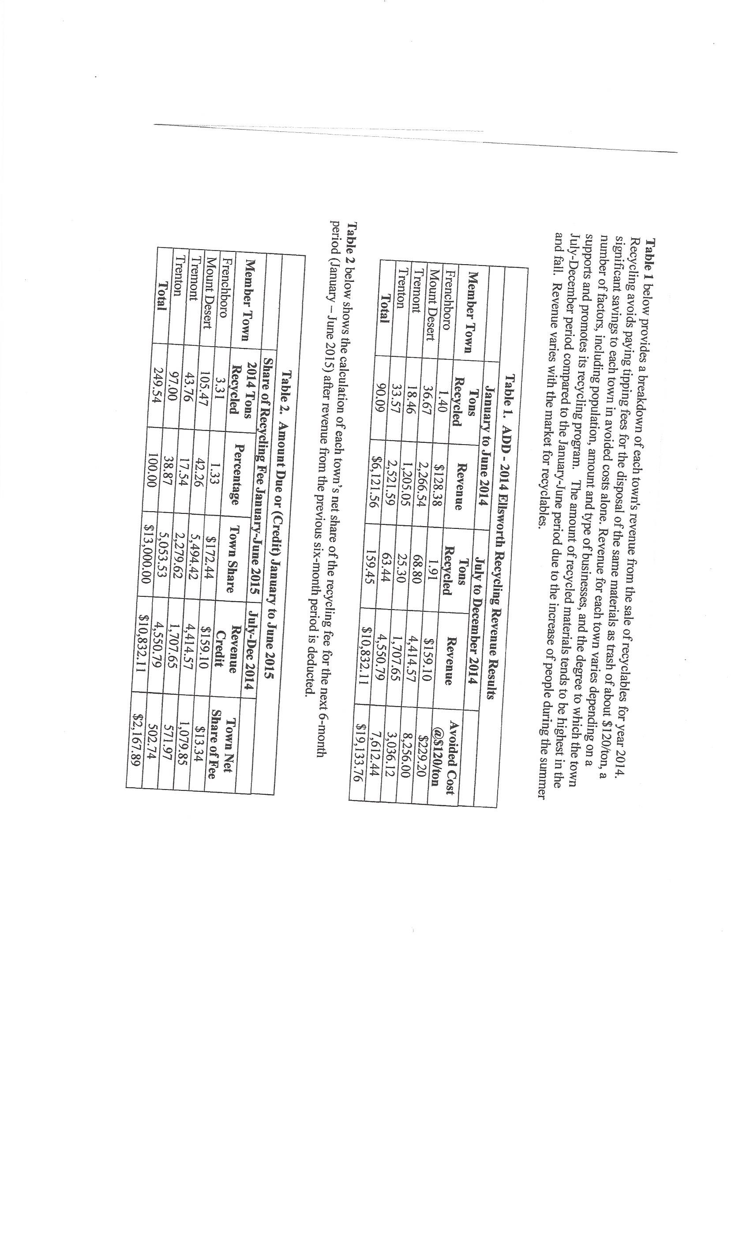
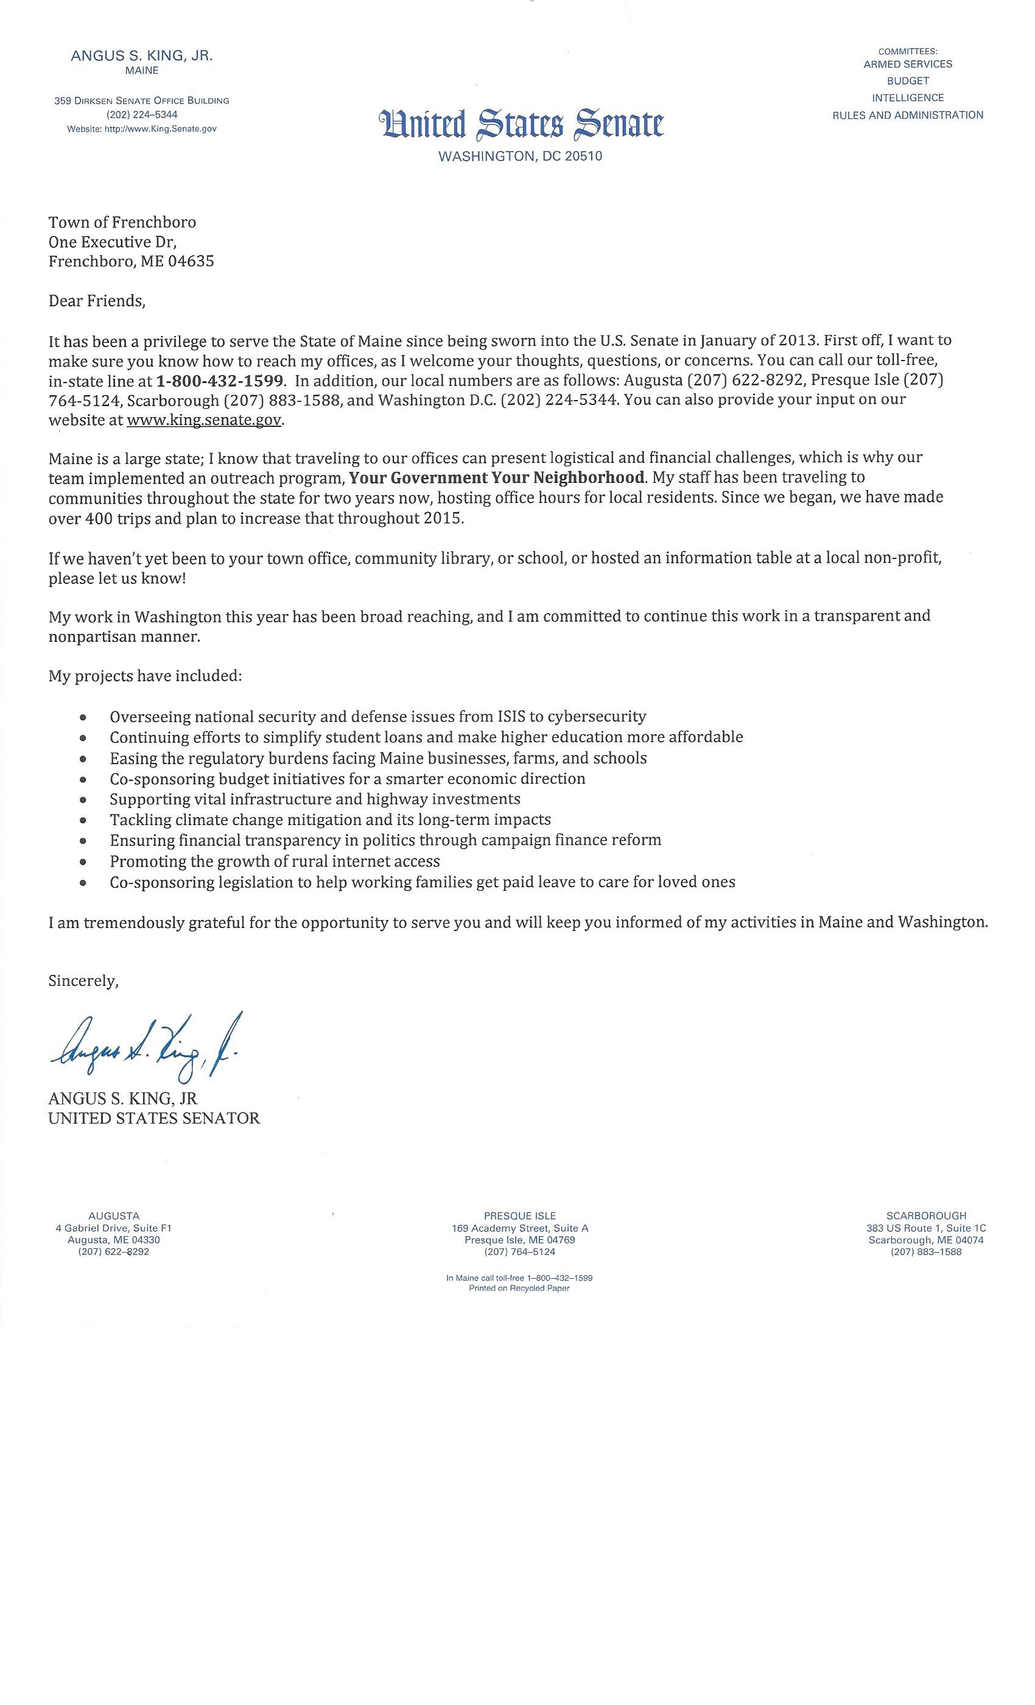
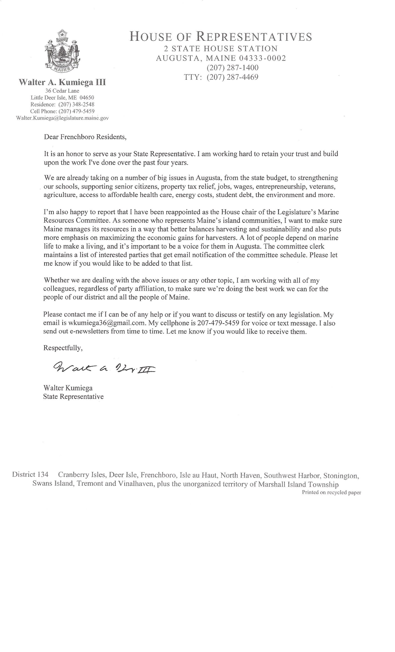
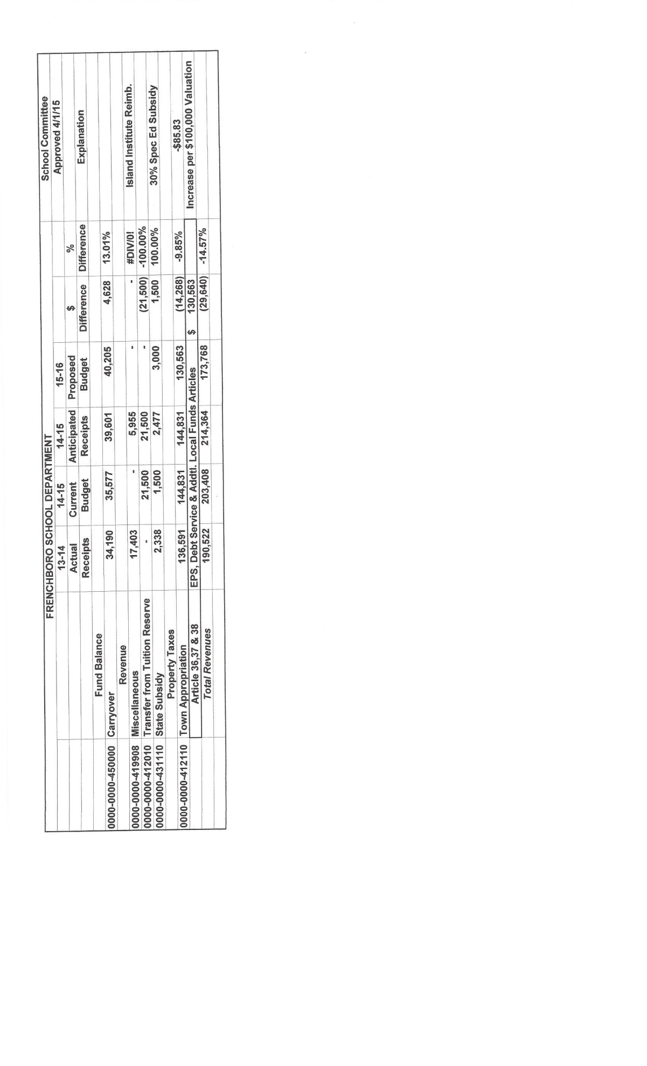
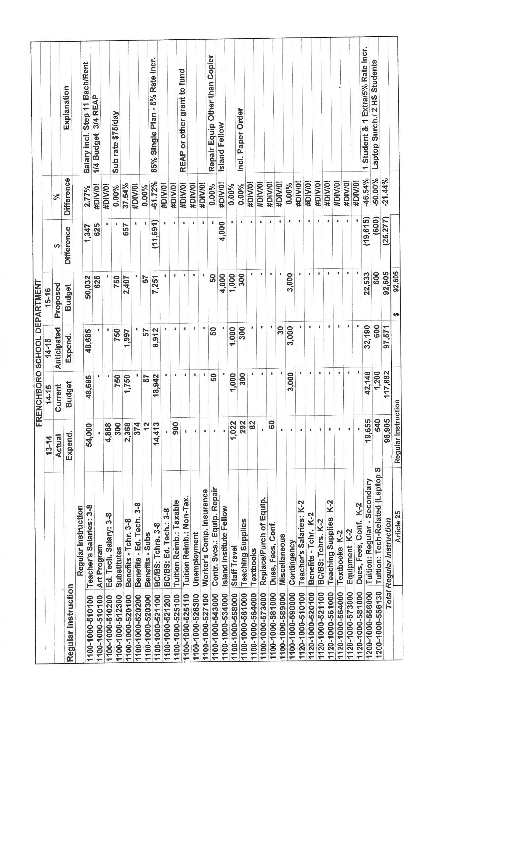
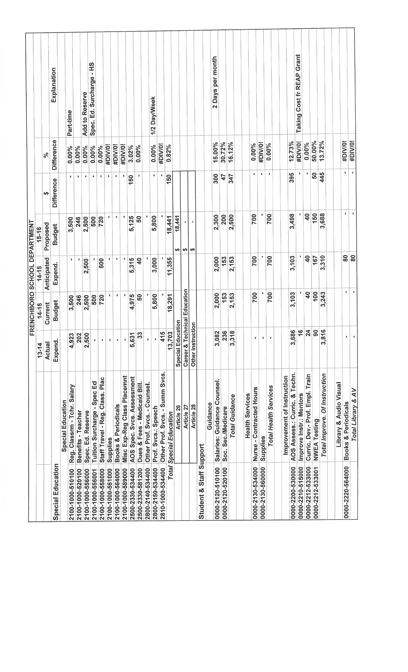
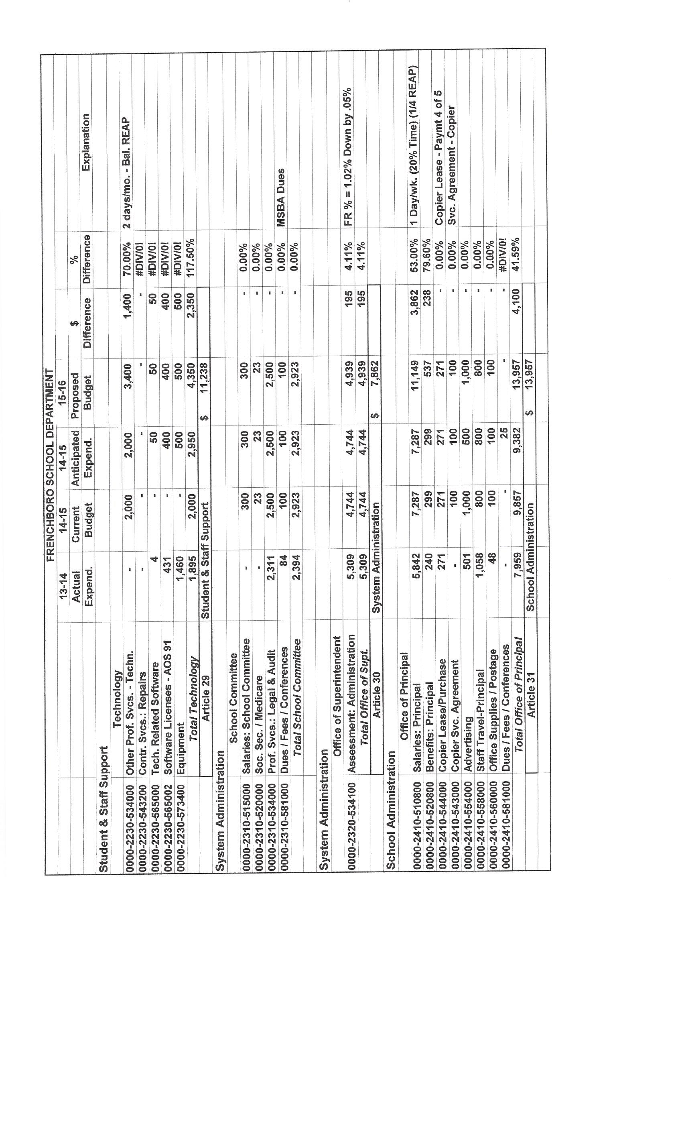
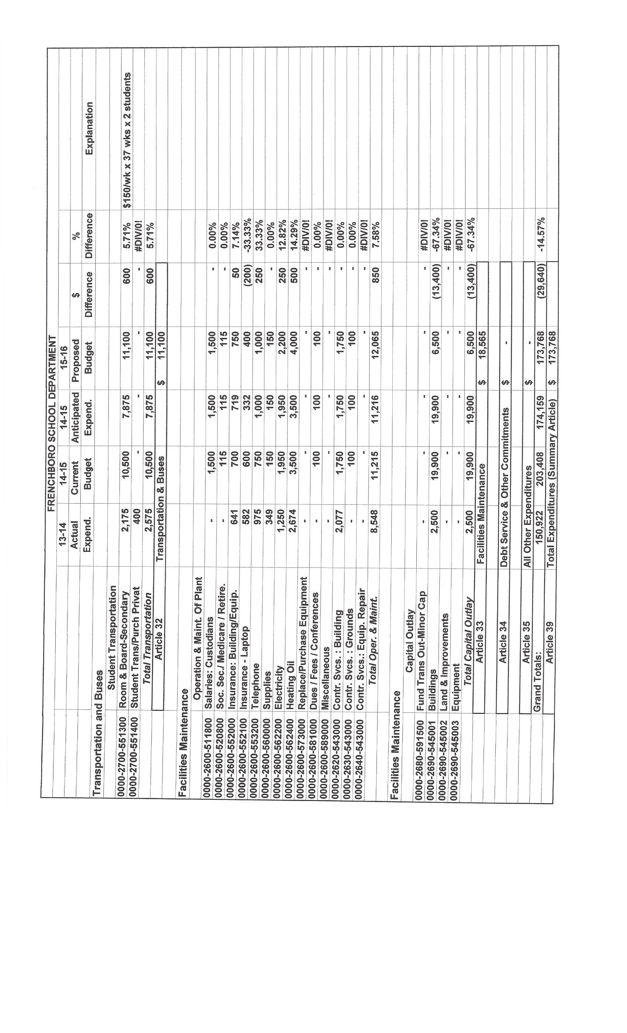
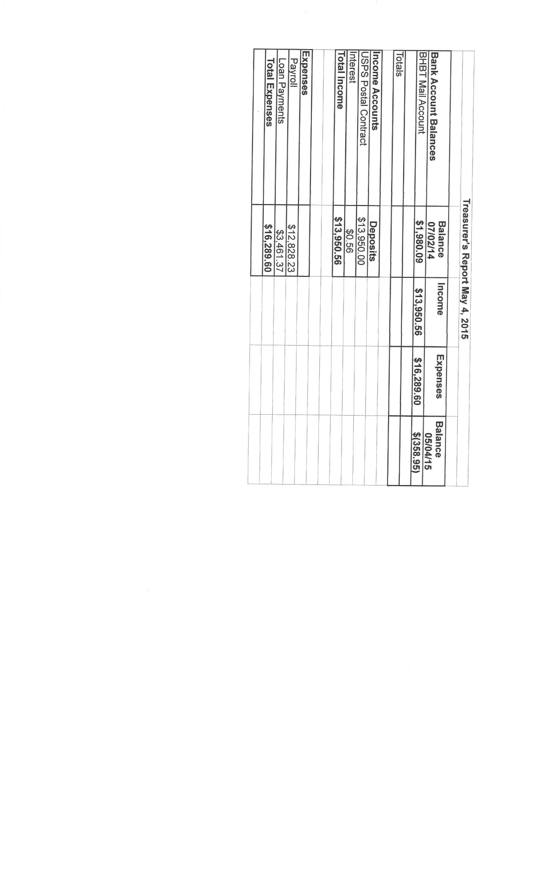
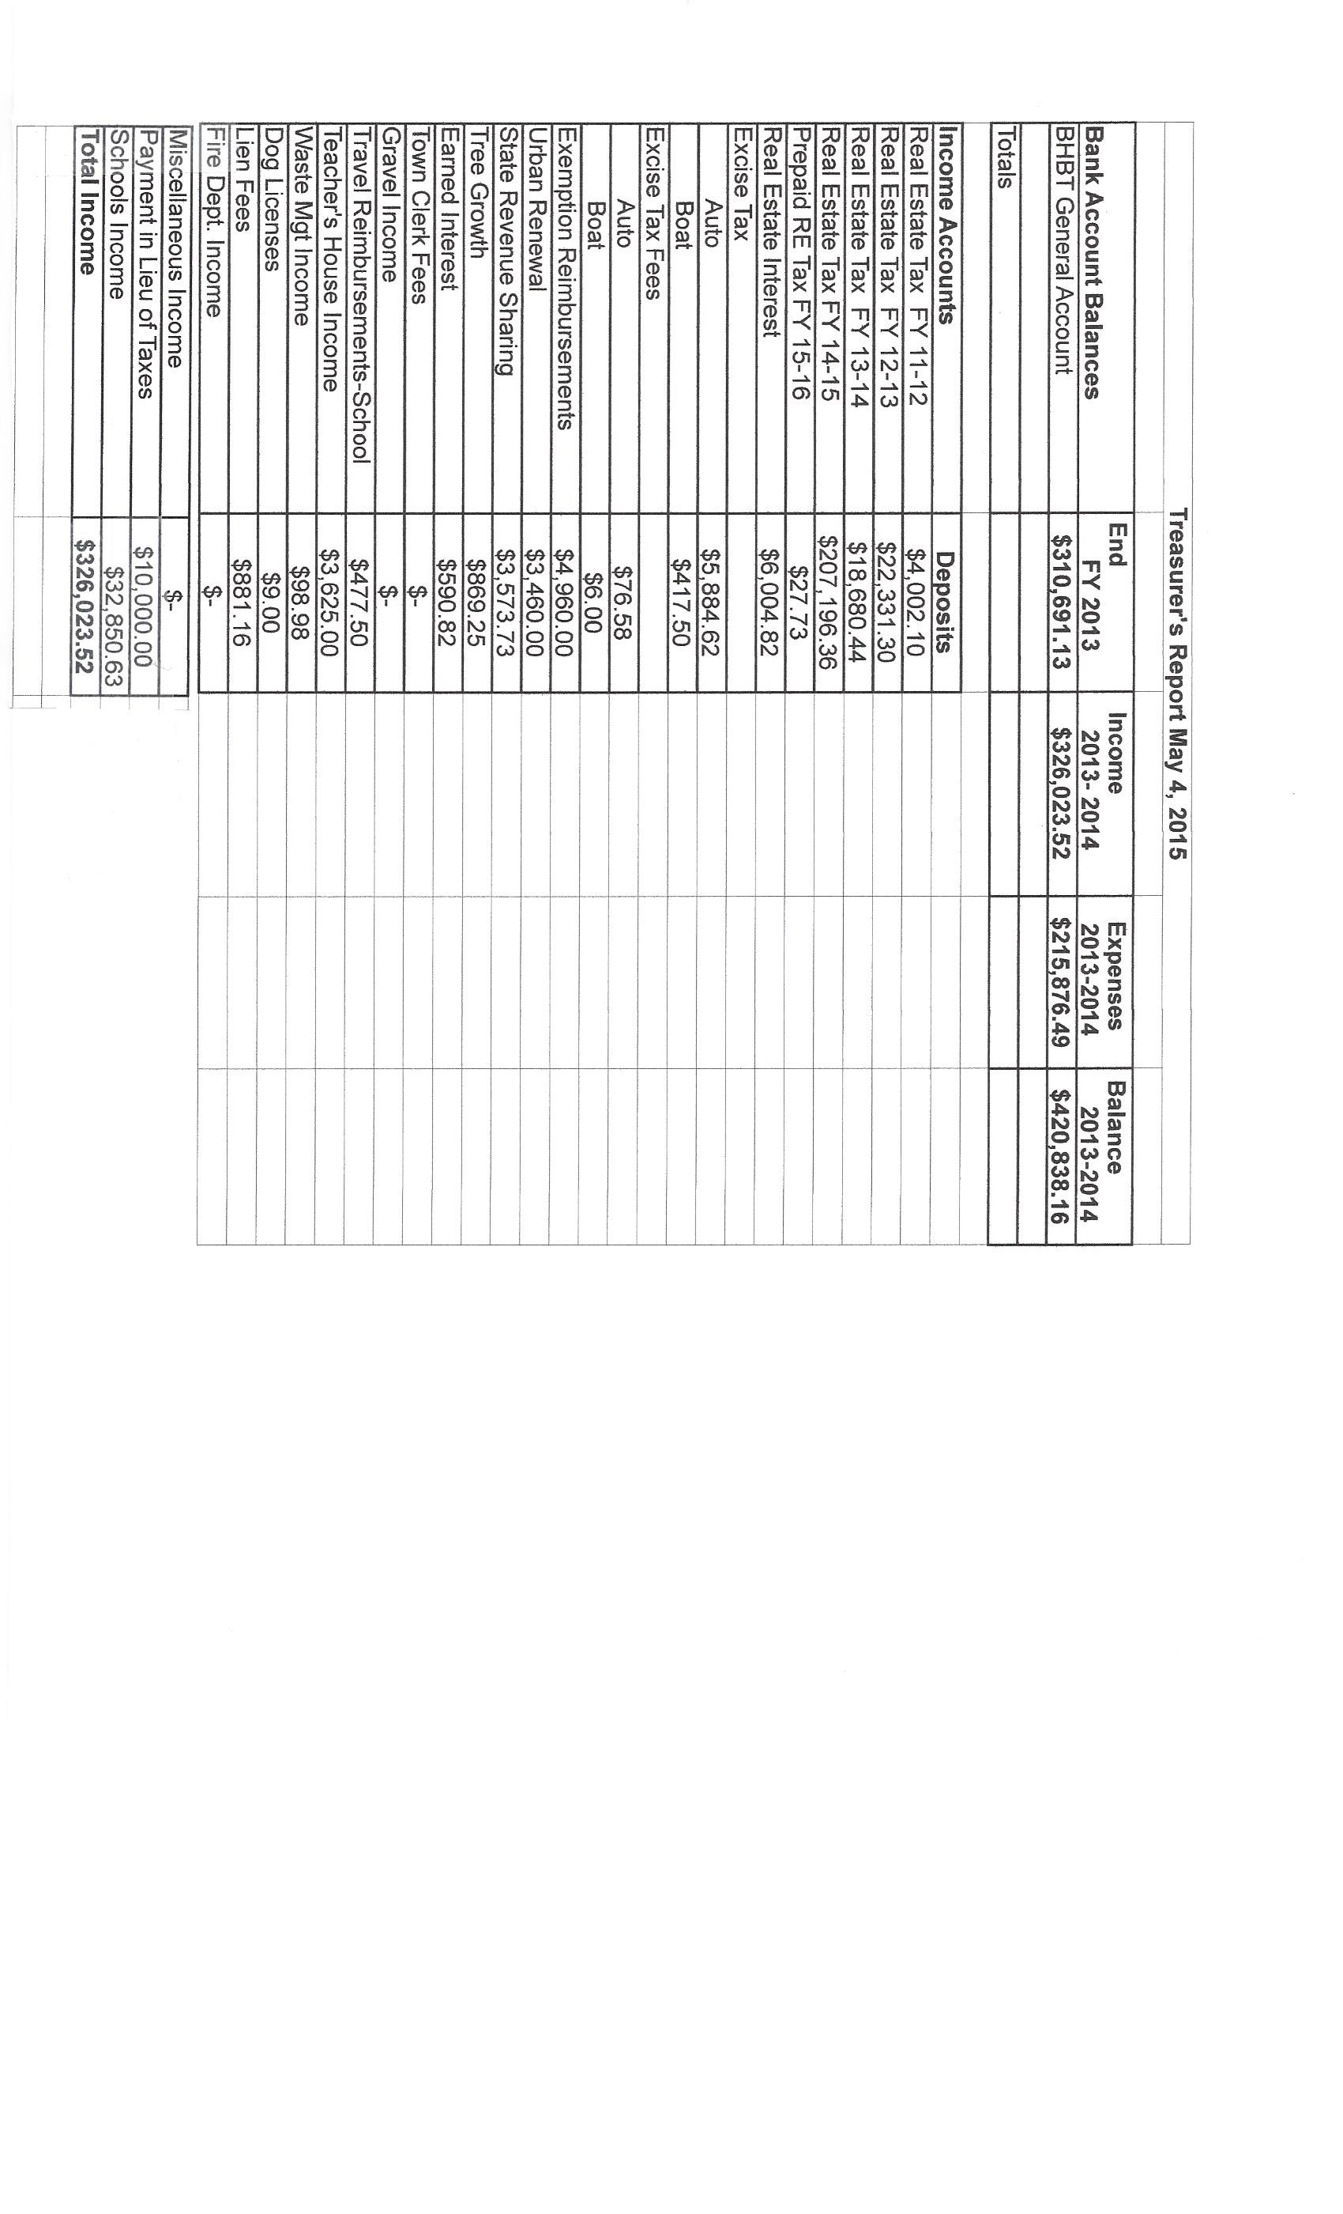
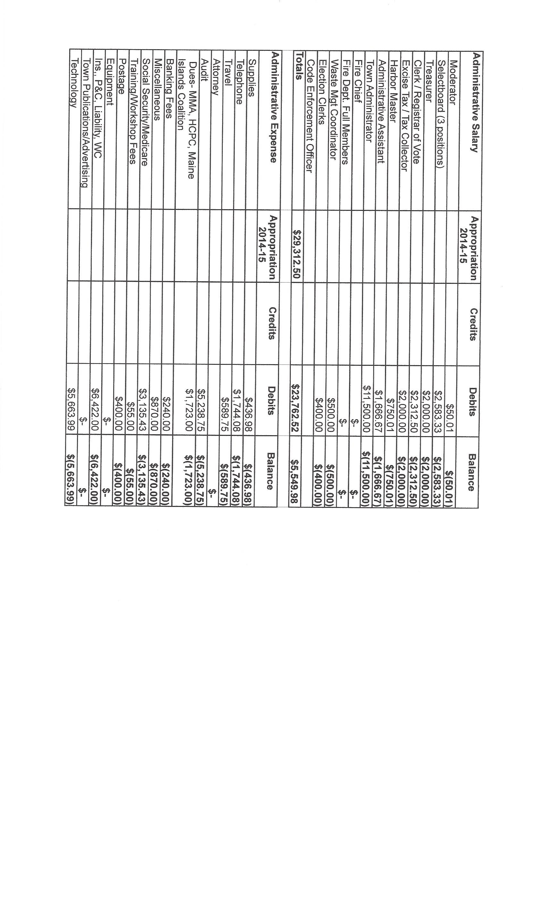
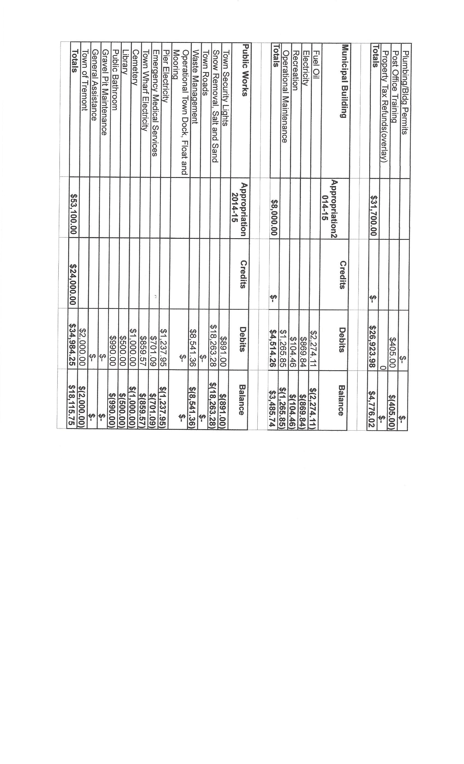
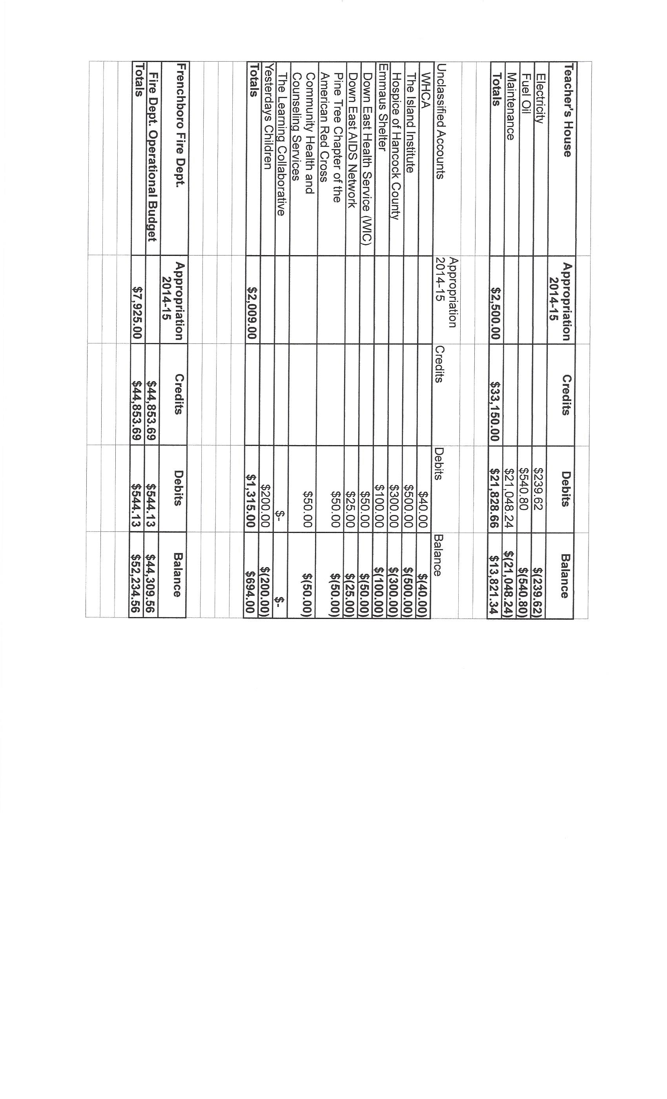
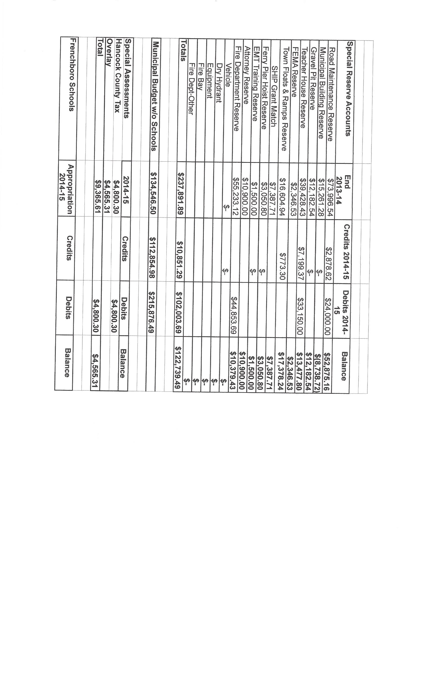
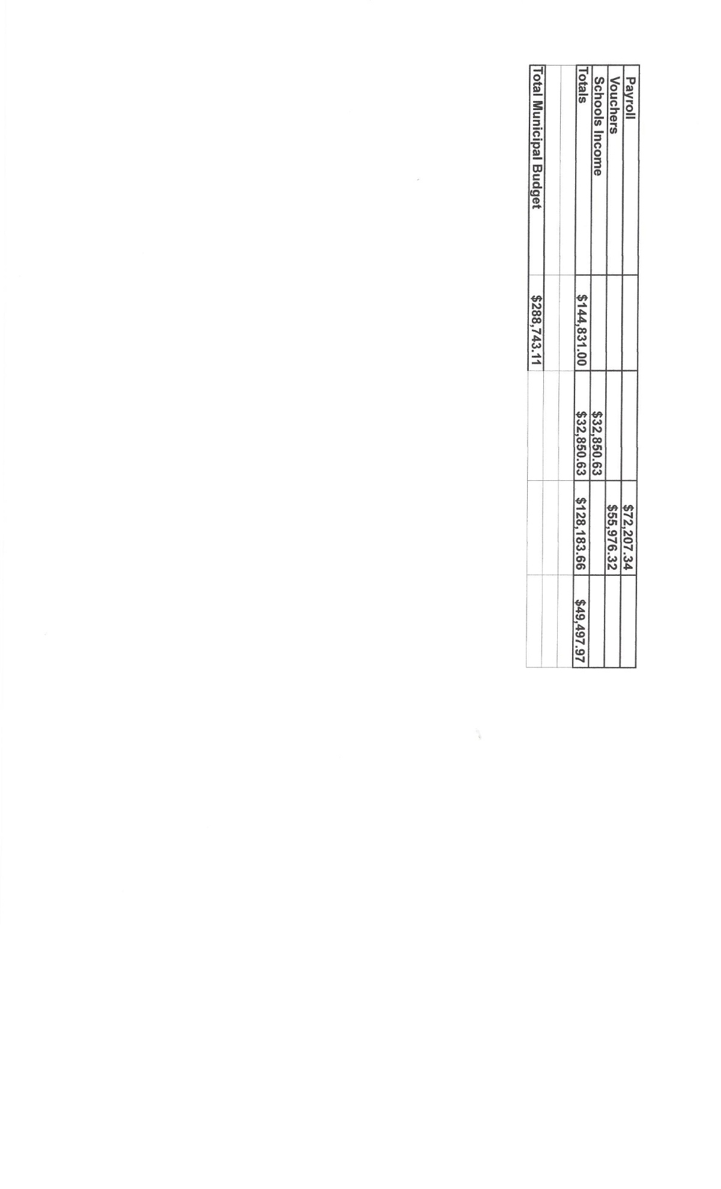
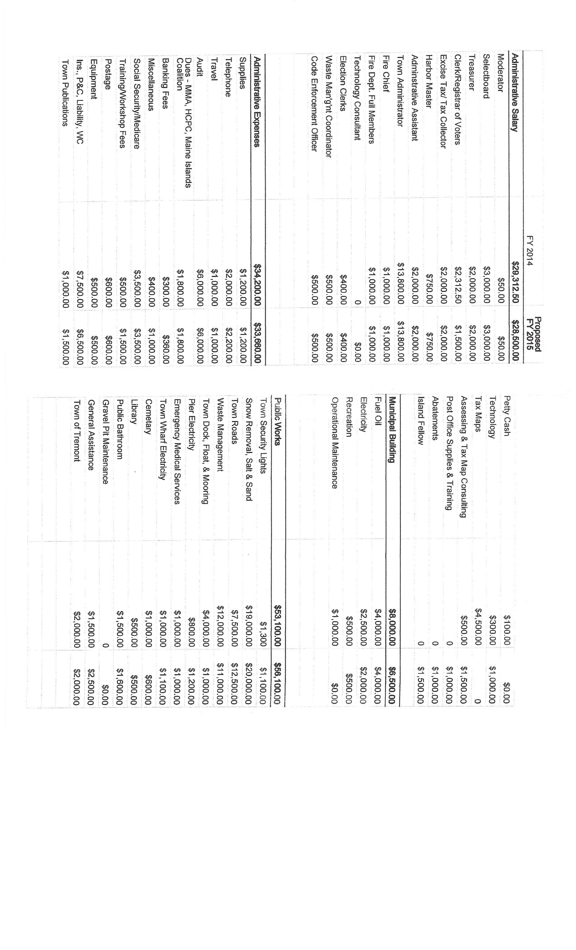
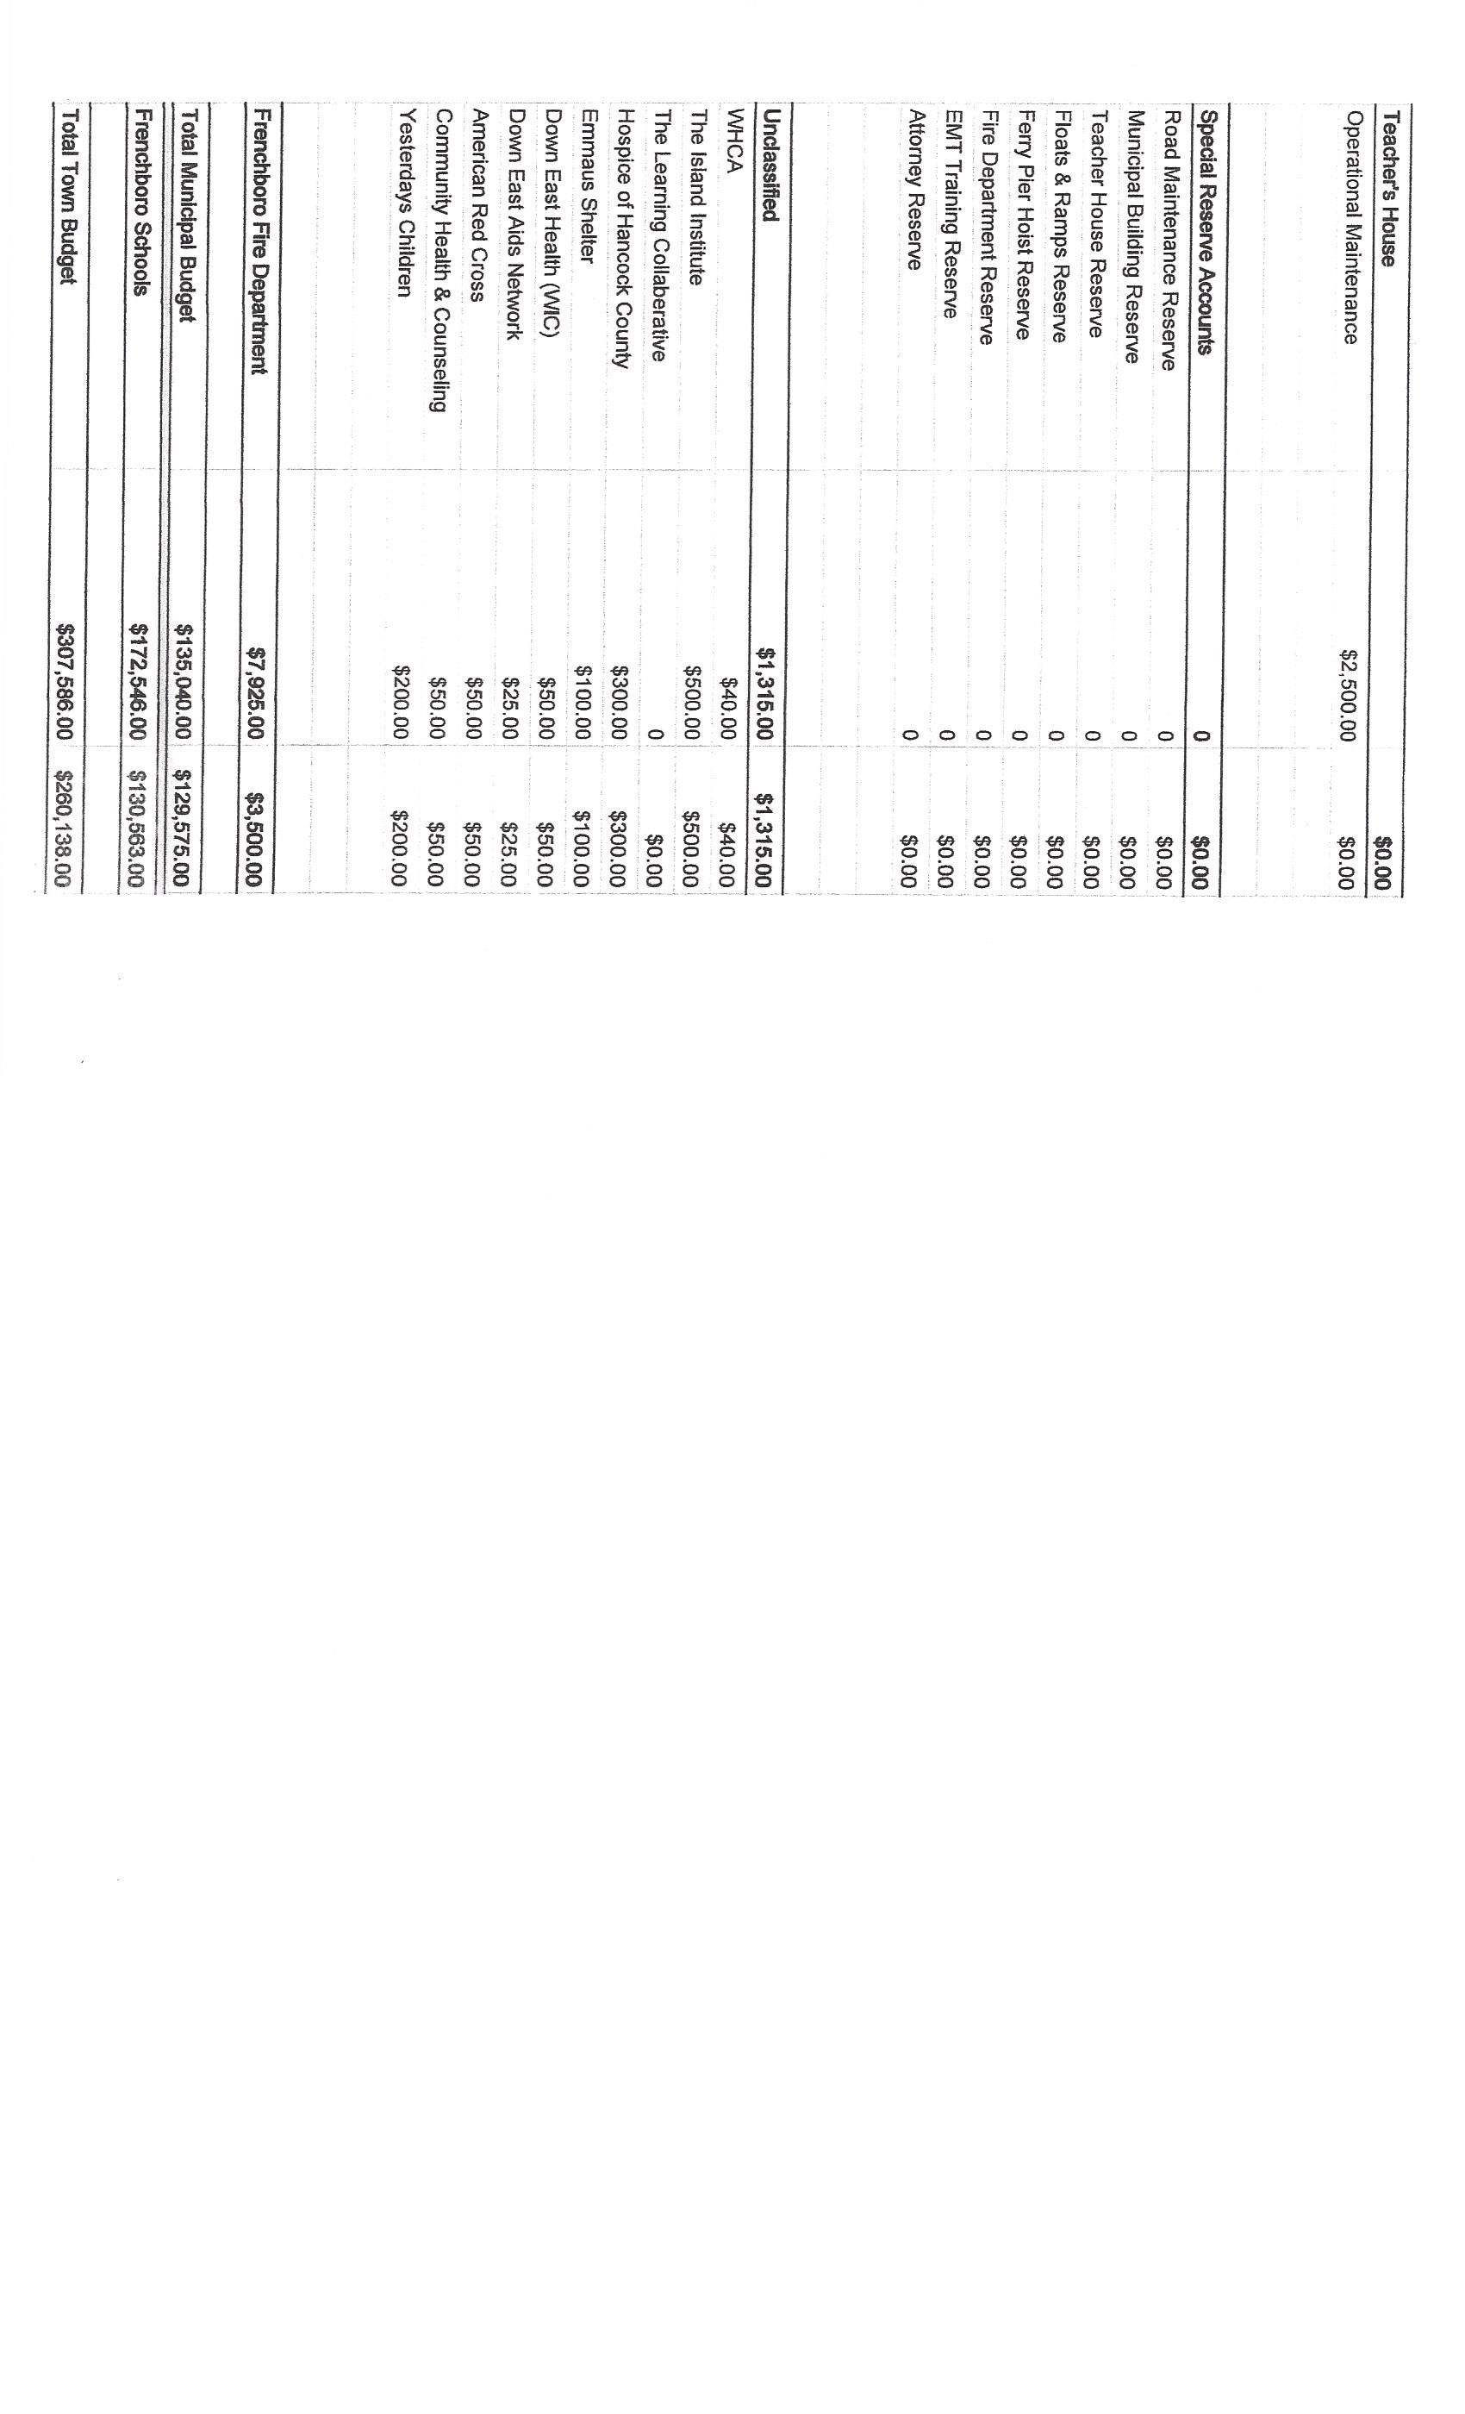
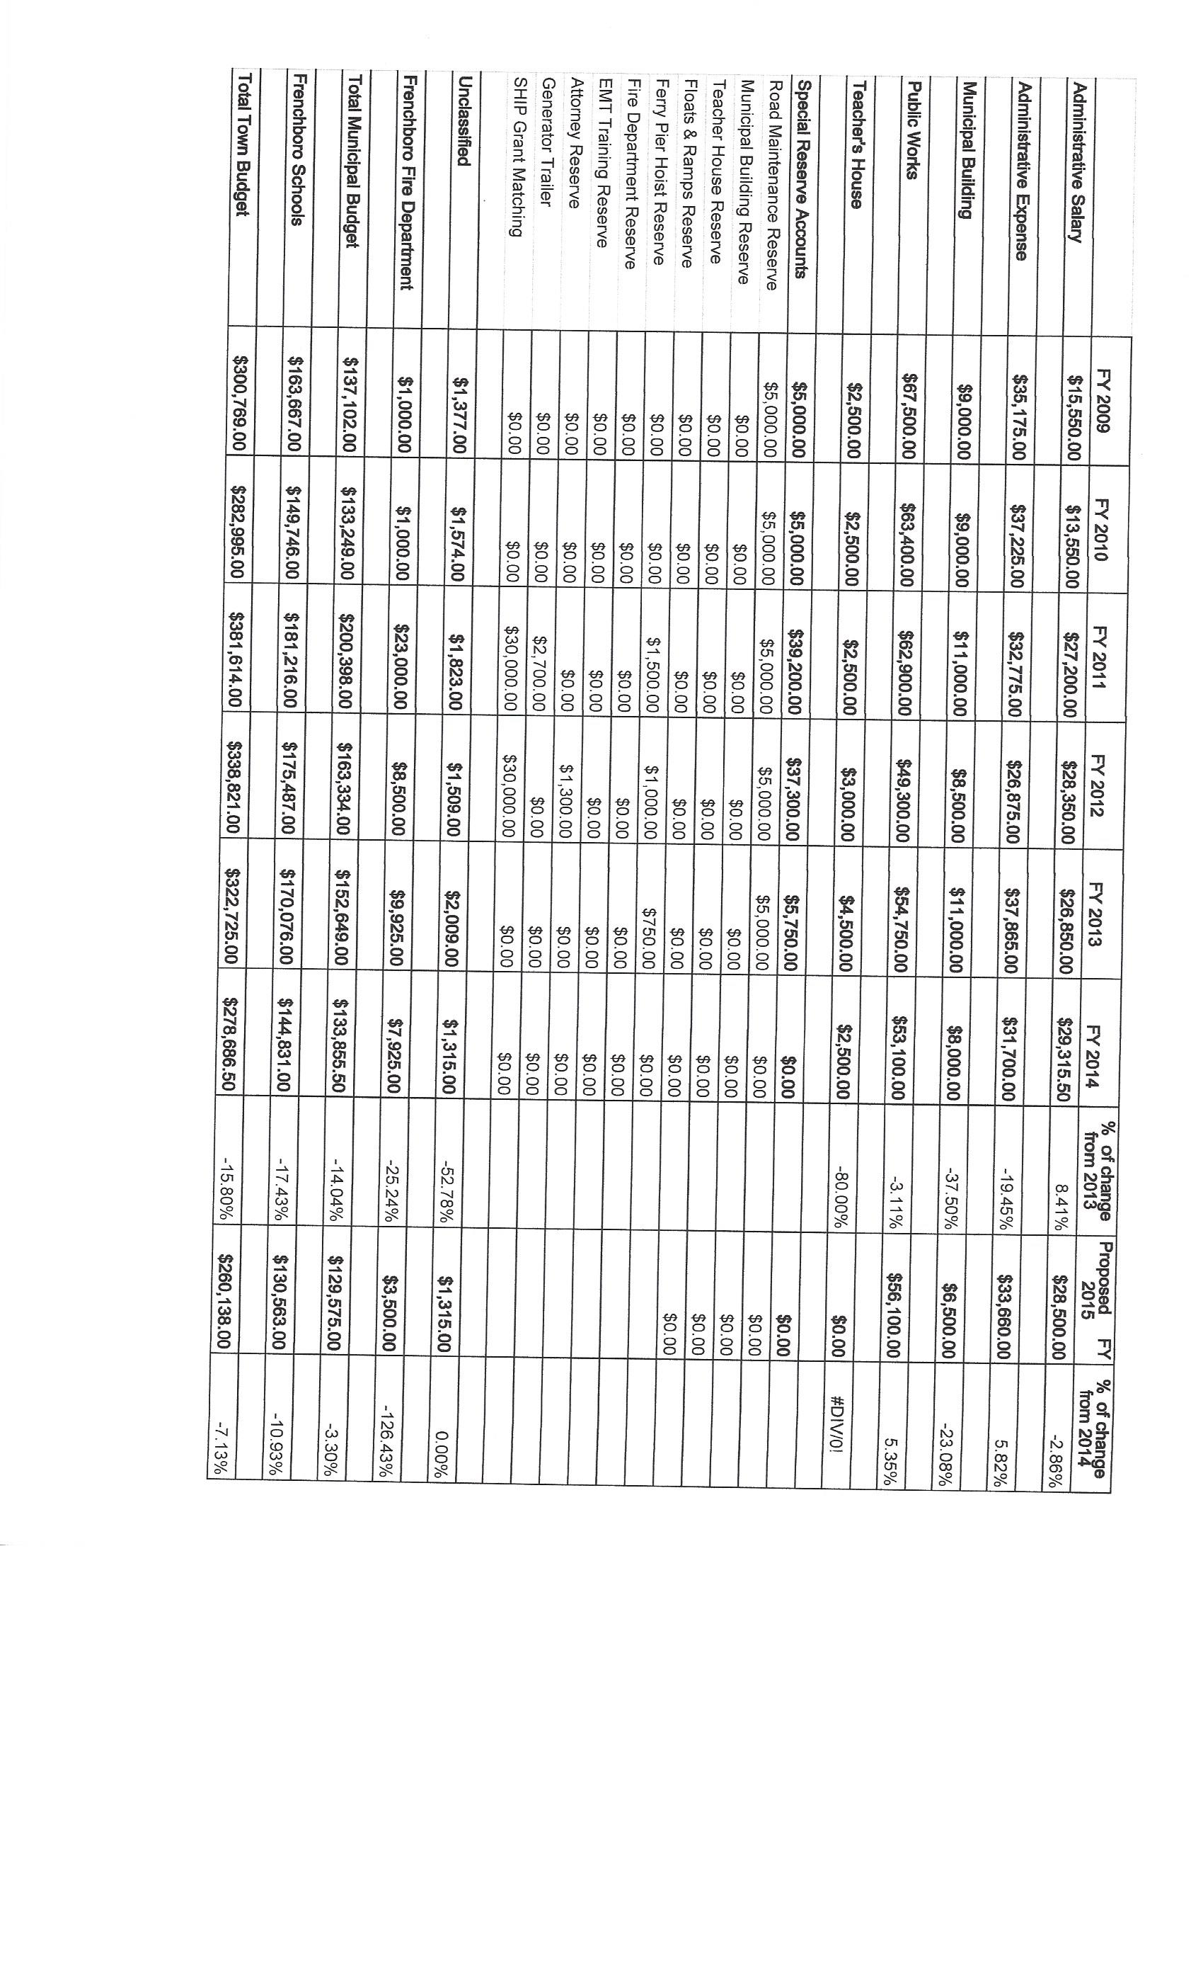
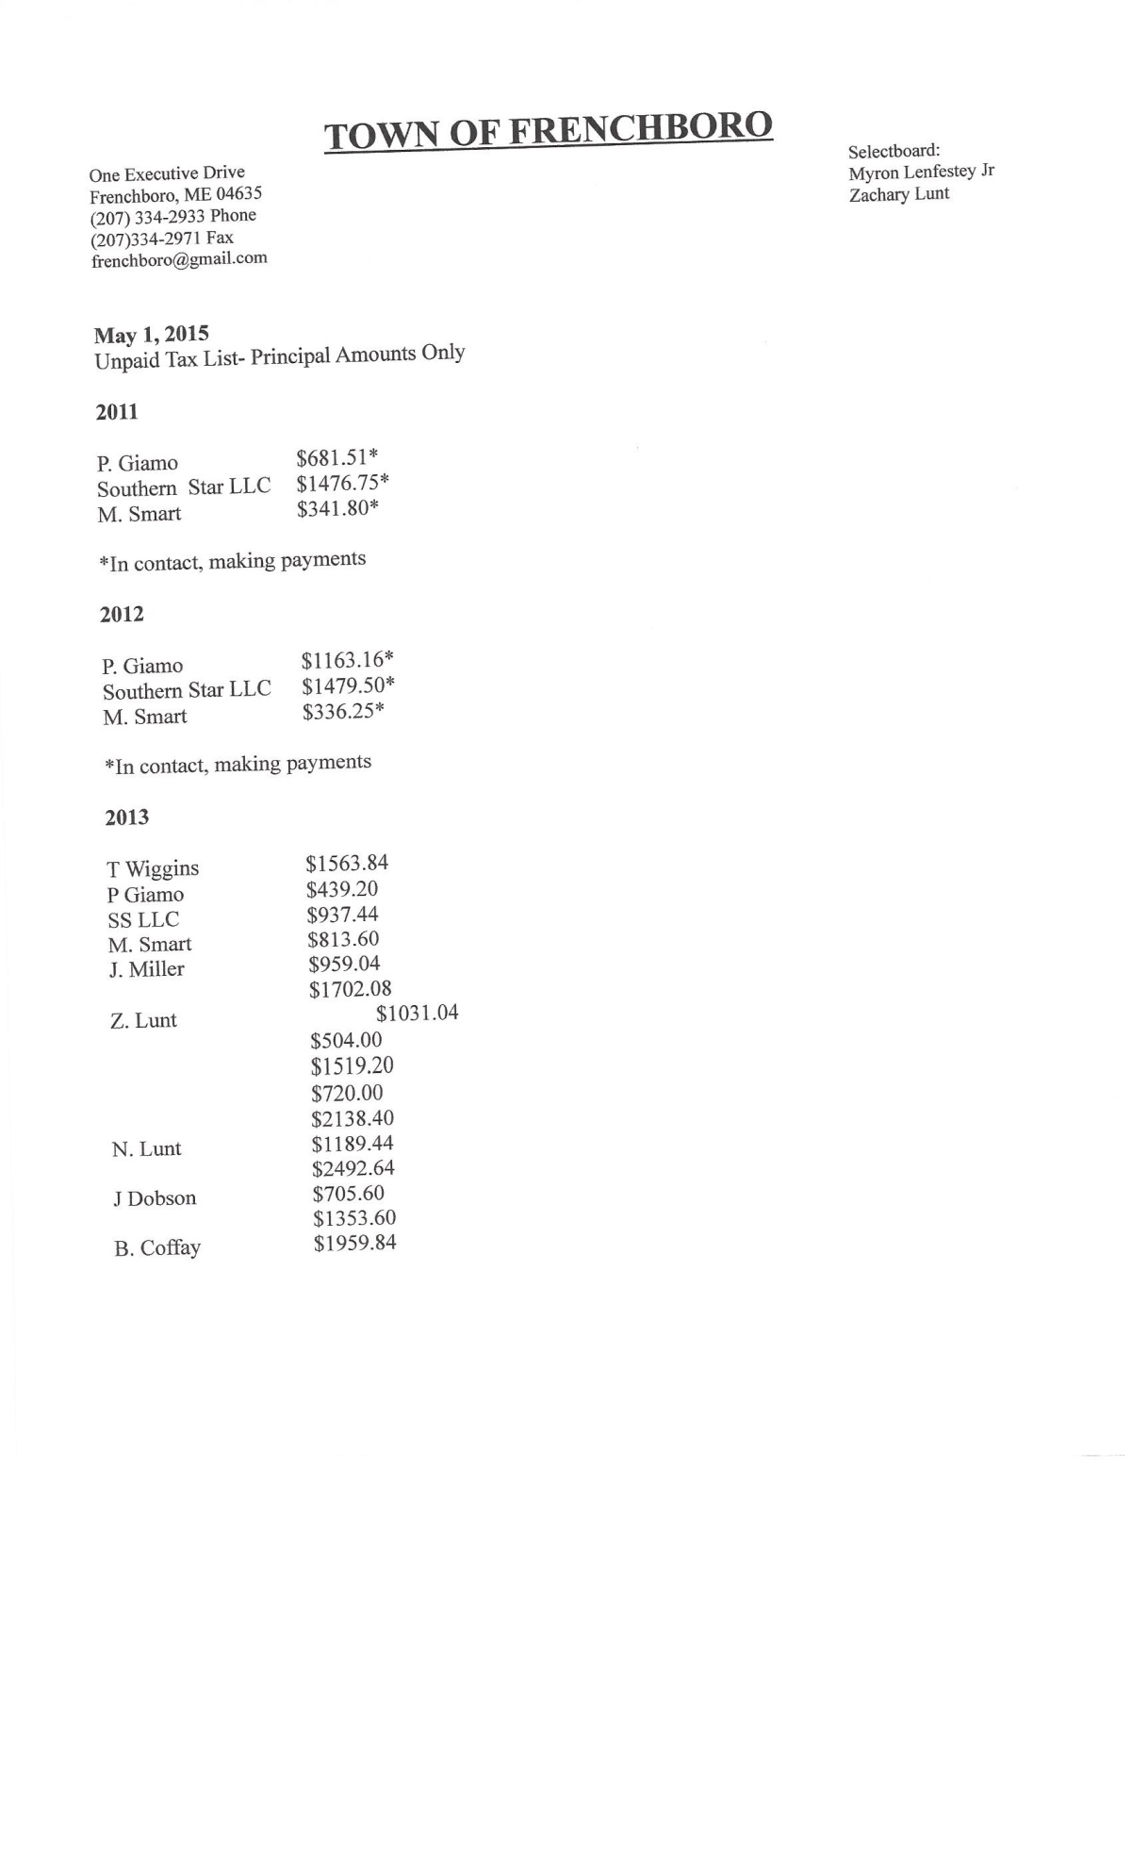
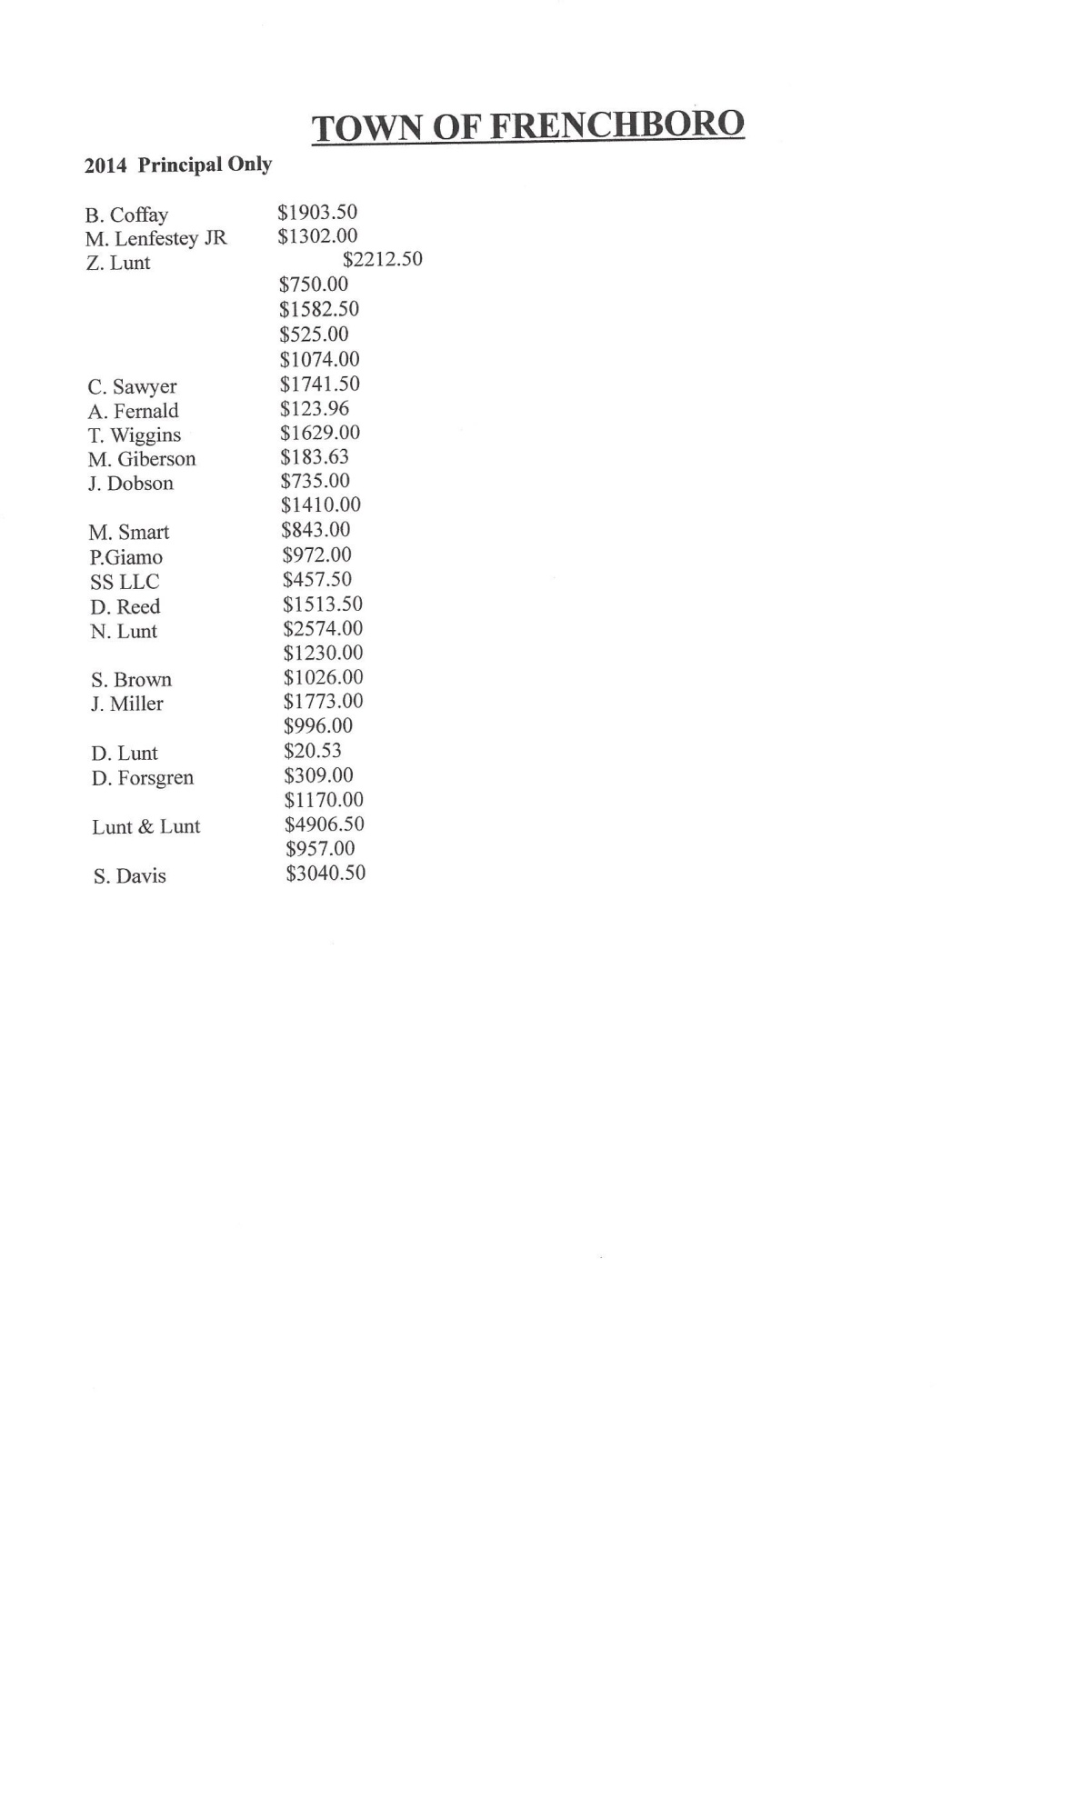
At the time of the printing of the Annual Town Report the Audit report was not ready. You can find excerpts of the Audit Report at frenchboro@maine.gov, or request a copy by email once they become available. Sorry for any inconvenience.

Sincerely,
Rebecca Lenfestey,
Town Administrator

